How to Apply Auto Gratuity on the PAD

Contents

Follow the steps below to learn how to apply Auto Gratuity on the PAD: 3

Auto Gratuity can be applied to a Table at any point before payment is taken.

# Follow the steps below to learn how to apply Auto Gratuity on the PAD:

1. From the Order screen, select the Number of Guests at the top left corner of the screen

[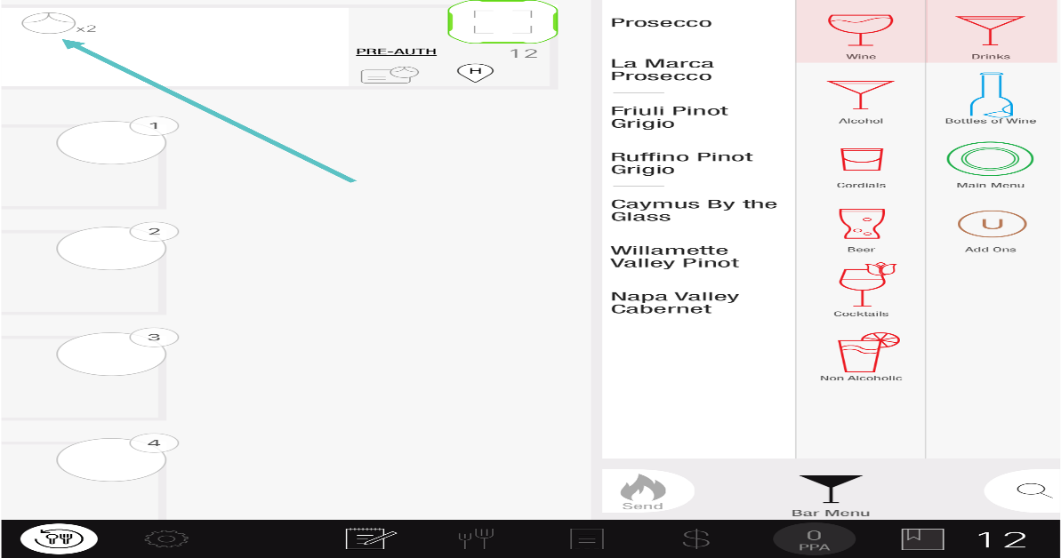](https://support-us.tabit.cloud/hc/article_attachments/16390056142482)

1. Select how to apply the Gratuity
   * **Apply Auto Gratuity:** Automatically applies the gratuity amount set in Tabit Office
   * **Apply Auto Gratuity Manually:** Allows you to select a percentage or dollar amount to apply as Auto Gratuity

[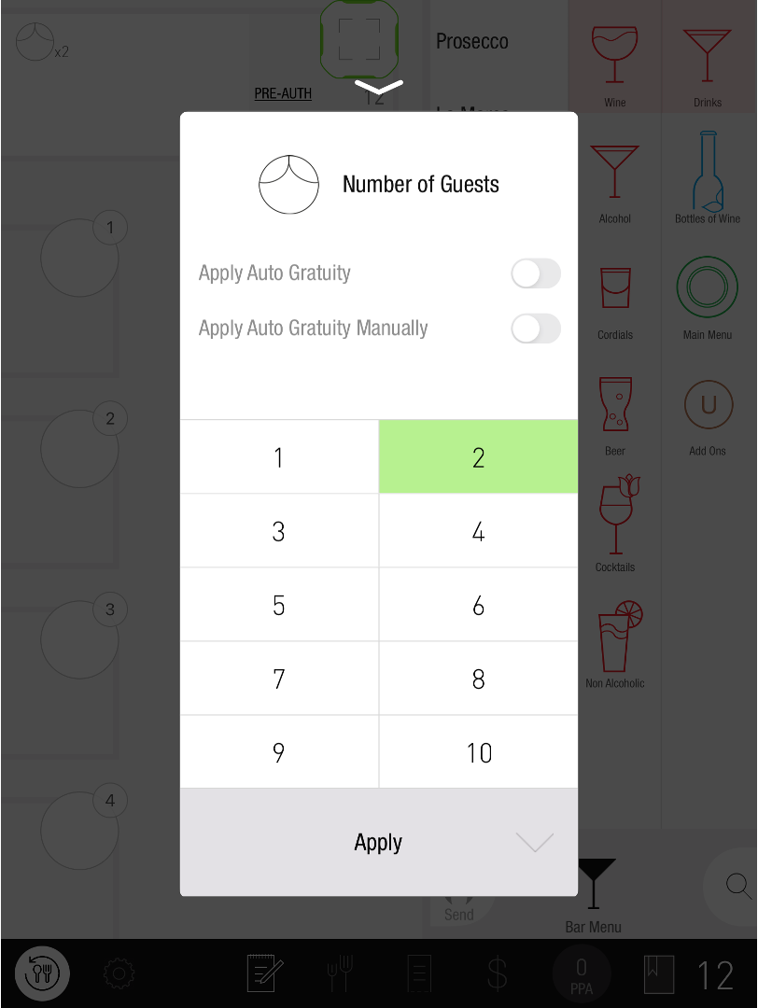](https://support-us.tabit.cloud/hc/article_attachments/16390056157074)

1. Tap Apply

[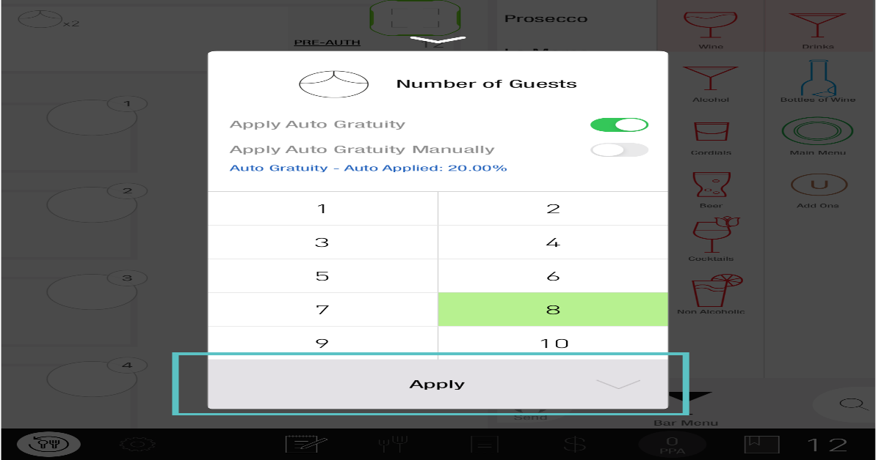](https://support-us.tabit.cloud/hc/article_attachments/16390068337554)

1. Now Auto Gratuity has been applied to the Order

[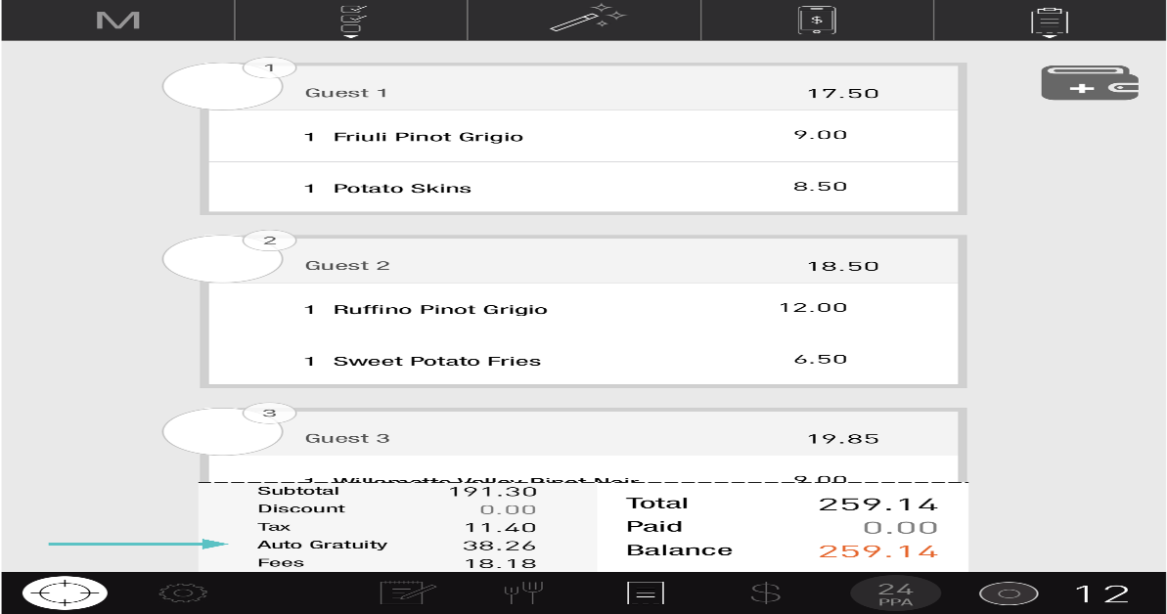](https://support-us.tabit.cloud/hc/article_attachments/16390068345874)

***If you need further assistance, please call Flyght Support at 419-724-3115 or send us an email:*** [***support@whatisflyght.com***](mailto:support@whatisflyght.com)