How to Mark a Takeaway Order as Taken

Contents

From the Payment screen 3

From the TD management screen 6

From the TD Actions tab 8

There are three ways to mark a takeaway Order as Taken on the PAD:

# From the Payment screen

1. On the PAD, complete the TD Order flow until payment is taken
2. Tap Mark Taken

[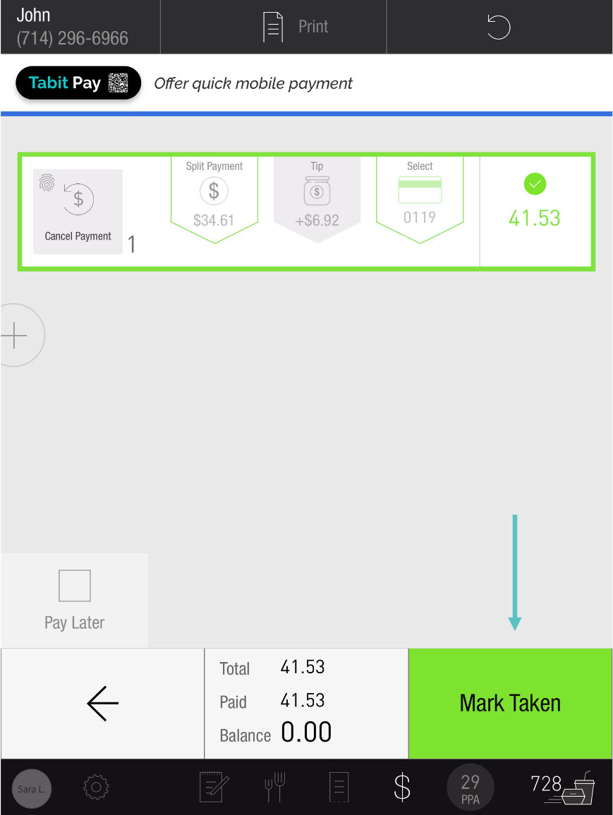](https://support-us.tabit.cloud/hc/article_attachments/16529199623186)

1. Select Close Order to close the Order

[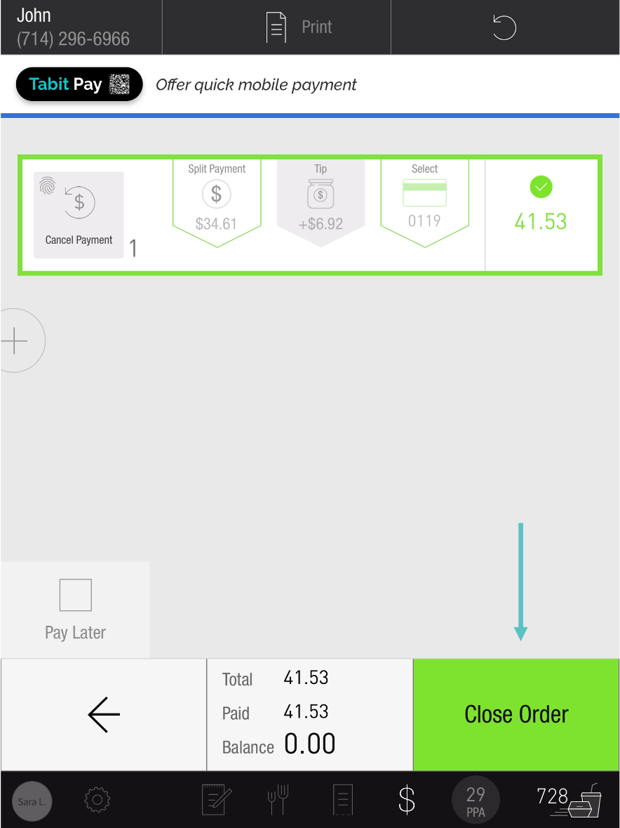](https://support-us.tabit.cloud/hc/article_attachments/16529199644434)

1. Now the Order has been marked as Taken and no longer appears on the TD Management screen

[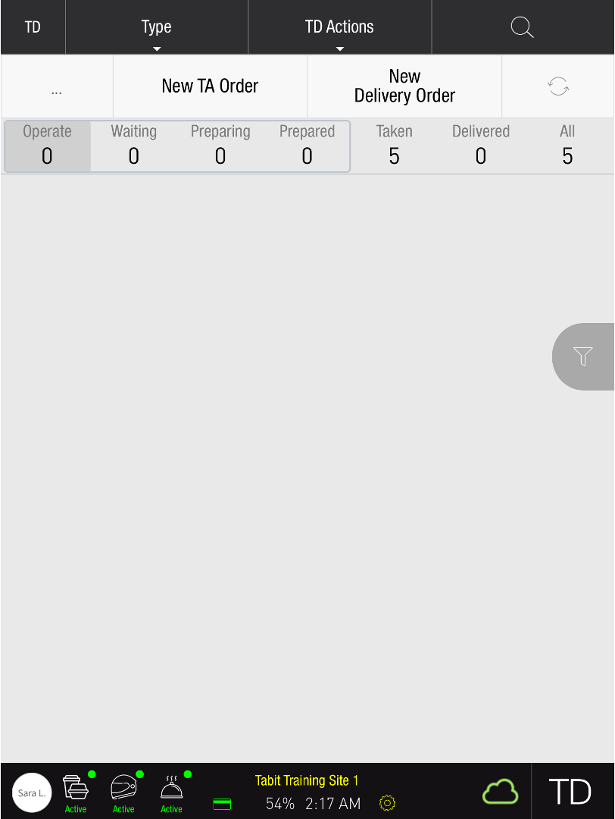](https://support-us.tabit.cloud/hc/article_attachments/16529199652882)

# From the TD management screen

1. On the TD Management screen, find the relevant Order and swipe right

[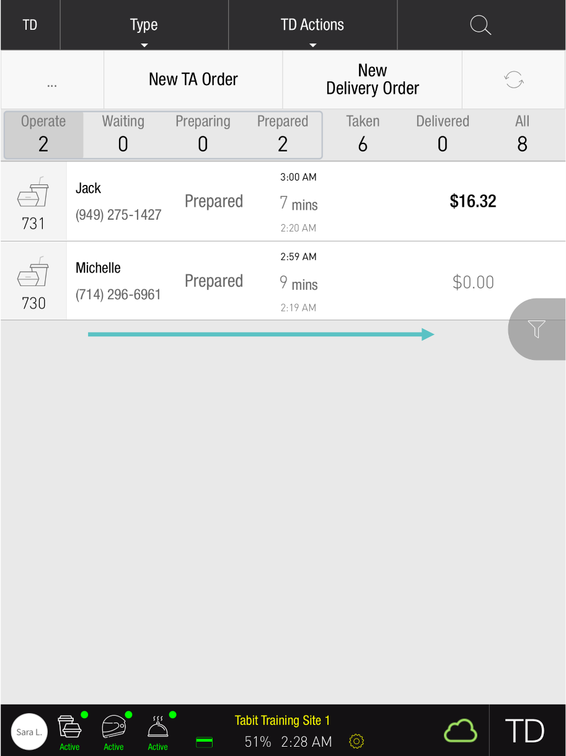](https://support-us.tabit.cloud/hc/article_attachments/16529153708562)

1. Select Taken

[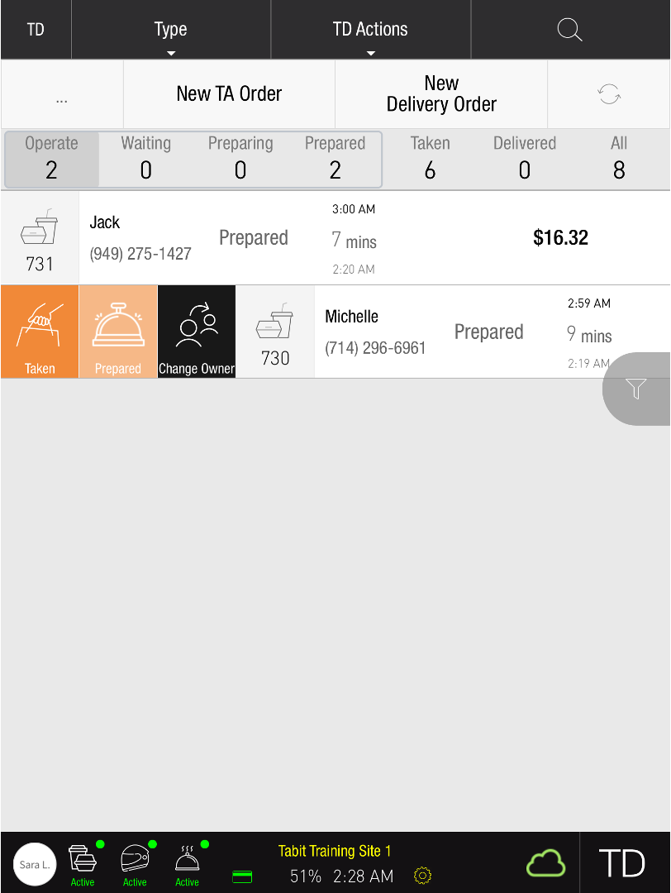](https://support-us.tabit.cloud/hc/article_attachments/16529153715858)

1. Now the Order has been marked as Taken

# From the TD Actions tab

1. Select TD Actions

[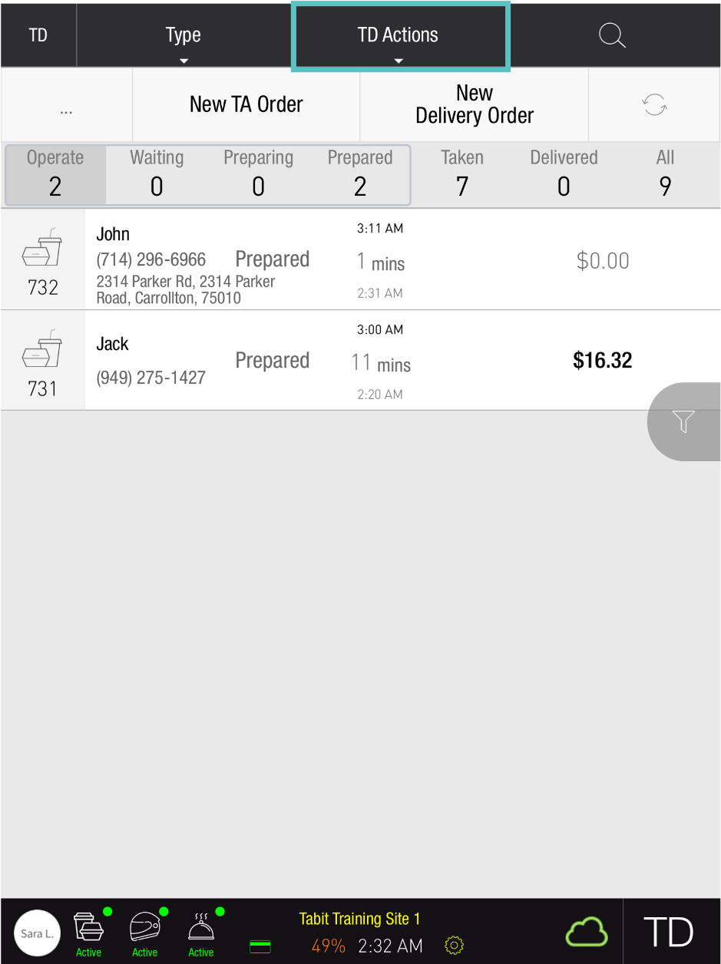](https://support-us.tabit.cloud/hc/article_attachments/16529153729938)

1. Select Mark Taken

[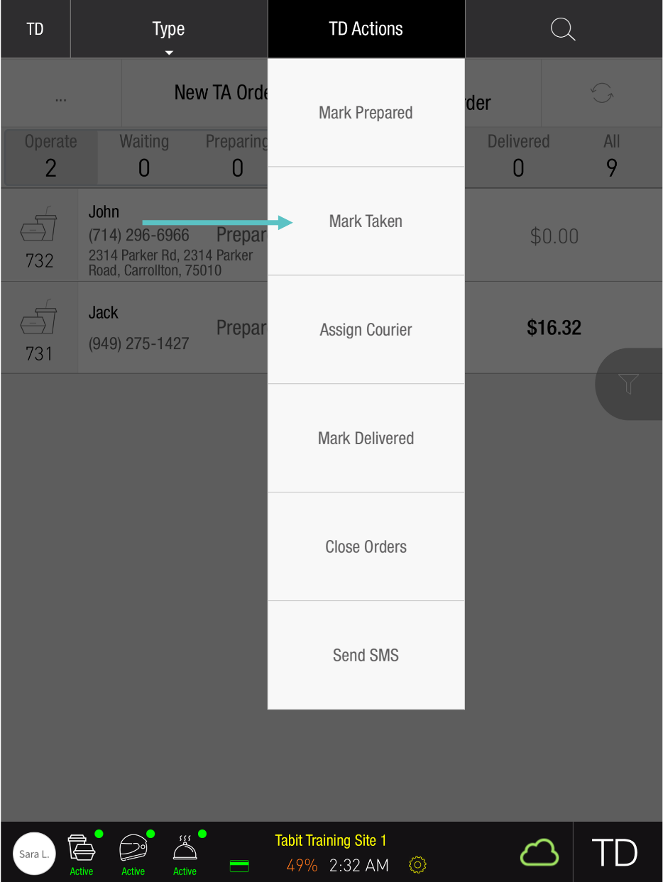](https://support-us.tabit.cloud/hc/article_attachments/16529199690642)

1. Select the relevant Order(s)

[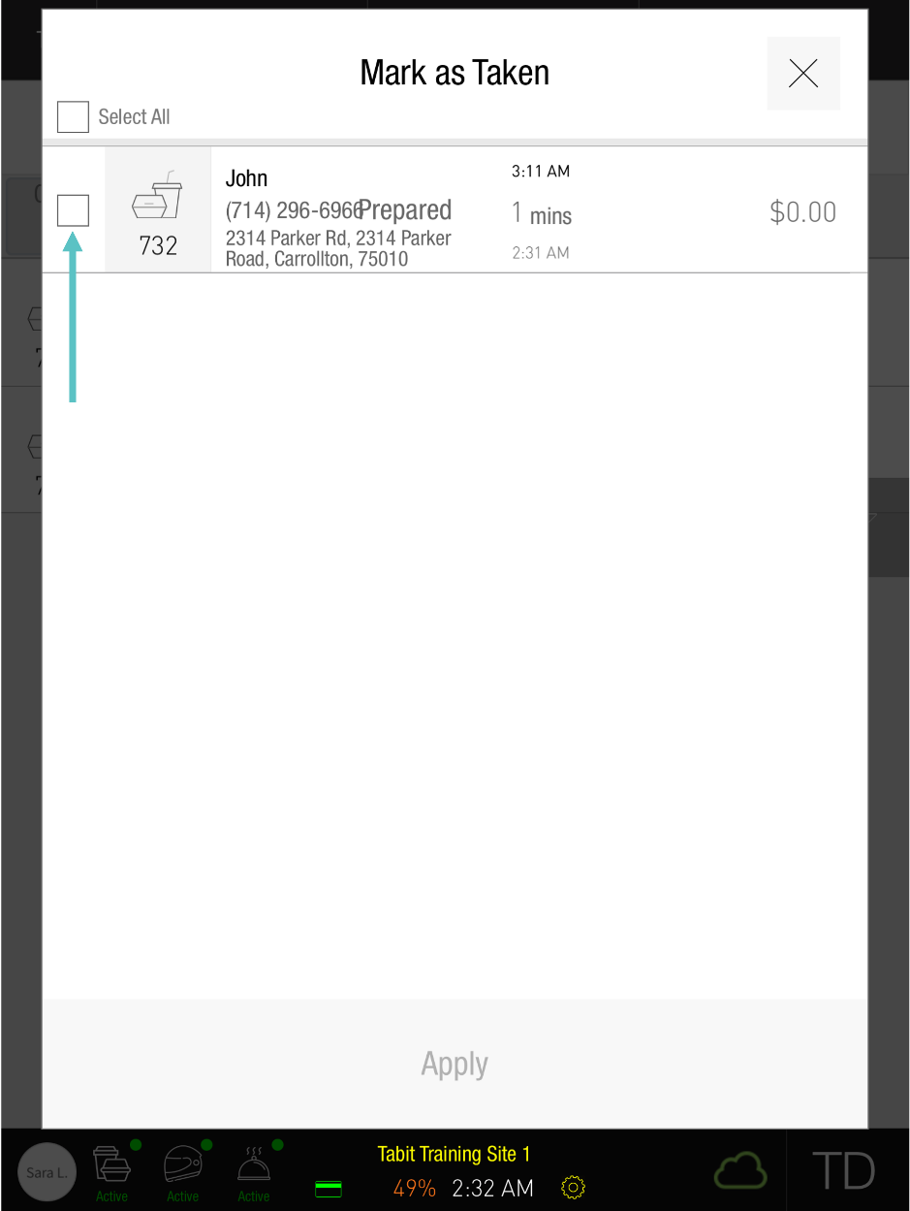](https://support-us.tabit.cloud/hc/article_attachments/16529153741714)

1. Select Apply

[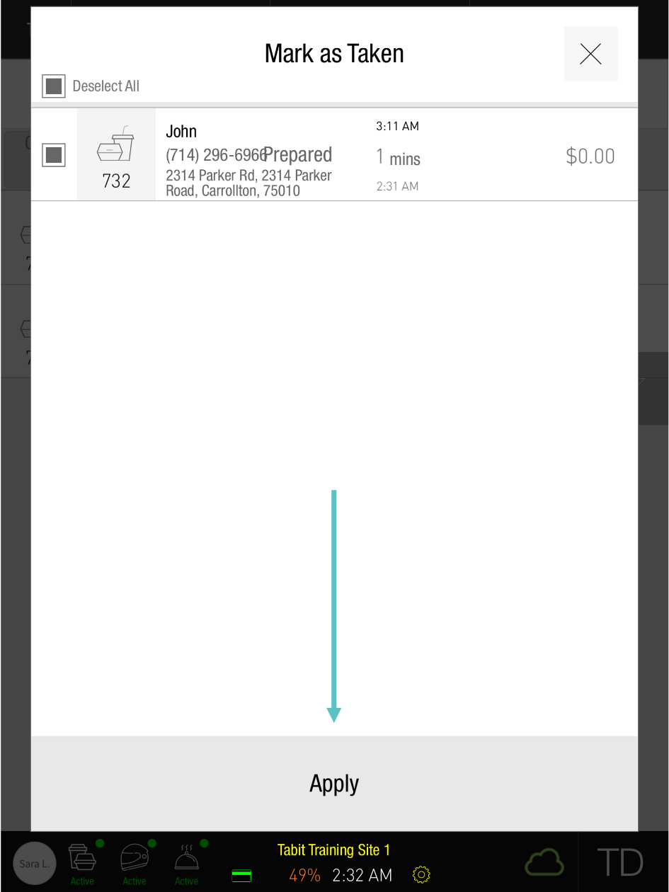](https://support-us.tabit.cloud/hc/article_attachments/16529199710354)

1. Now the Order has been marked as Taken and no longer appears on the TD screen

[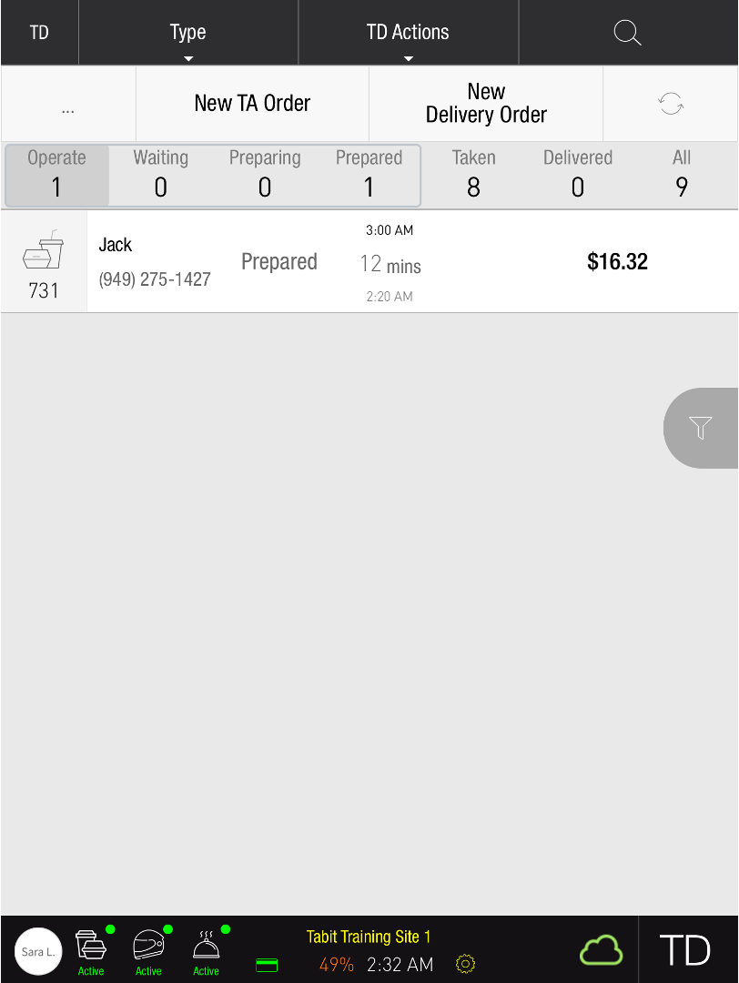](https://support-us.tabit.cloud/hc/article_attachments/16529199723154)

***If you need further assistance, please call Flyght Support at 419-724-3115 or send us an email:*** [***support@whatisflyght.com***](mailto:support@whatisflyght.com)