Printing a Check

Contents

To print checks from the PAD follow the steps below: 3

Option 1 3

Option 2 4

# To print checks from the PAD follow the steps below:

## ****Option 1****

1. Open the requested Order and go to the Check screen
2. Tap on the check presenter icon in the upper right-hand corner

[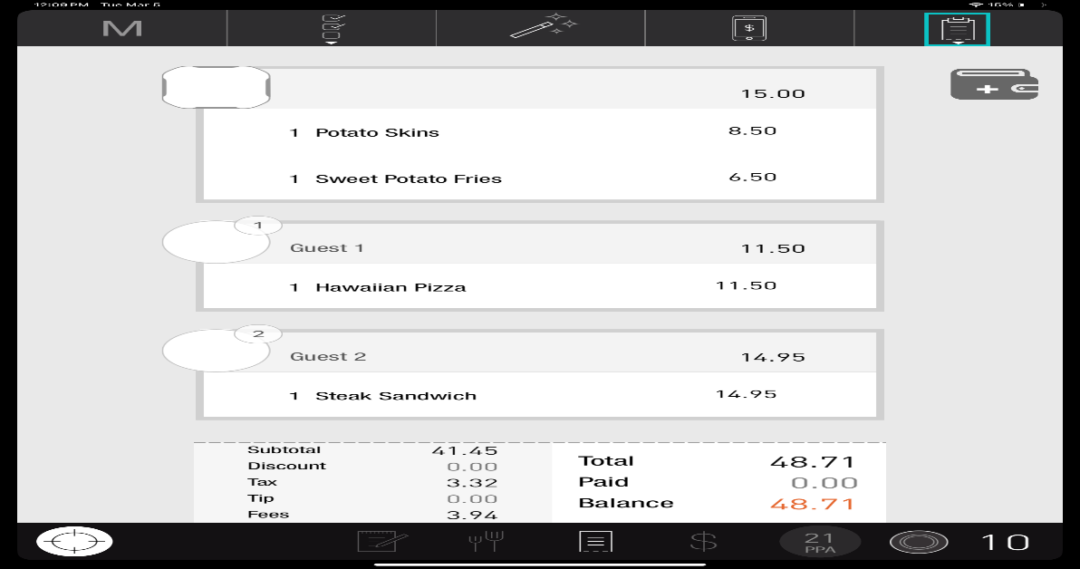](https://support-us.tabit.cloud/hc/article_attachments/17627044662034)

1. Select the desired printer and confirm your selection

[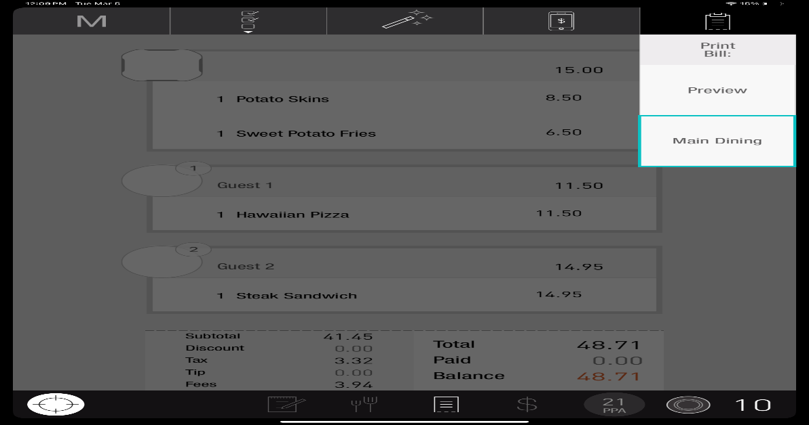](https://support-us.tabit.cloud/hc/article_attachments/17627005195026)

1. The check will now print

[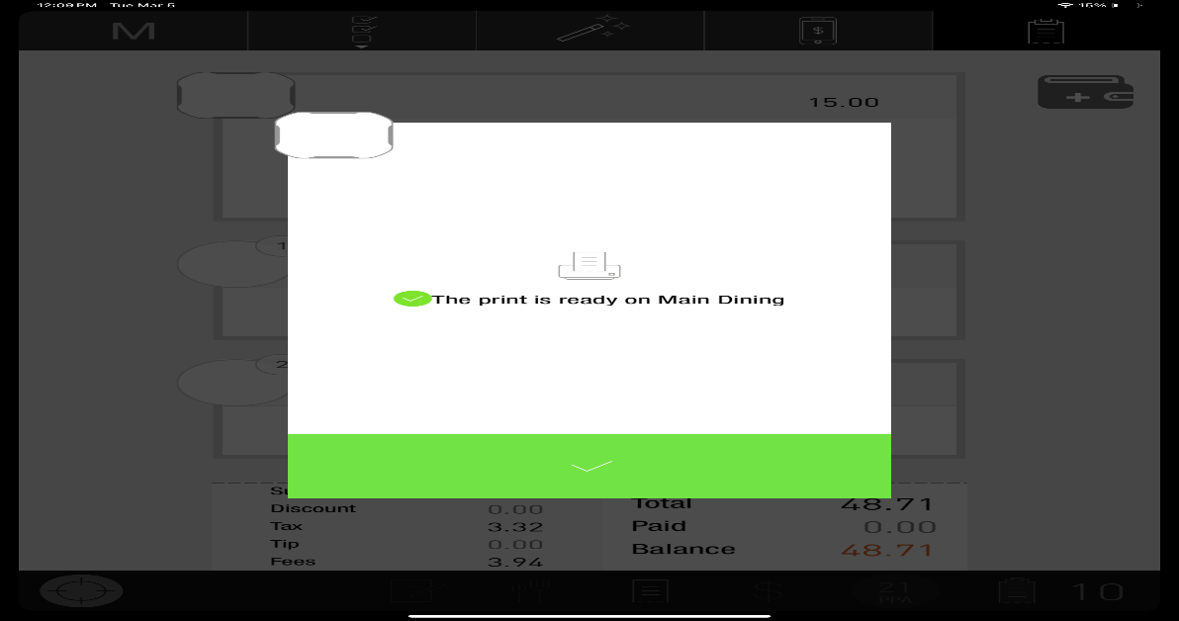](https://support-us.tabit.cloud/hc/article_attachments/17627044685074)

## ****Option 2****

1. Go to the Tables screen and locate the desired Order

[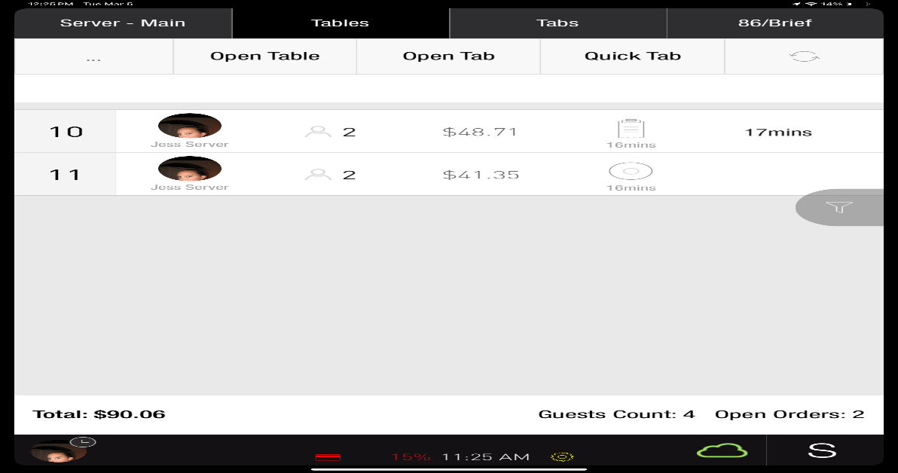](https://support-us.tabit.cloud/hc/article_attachments/17627044690706)

1. Right-swipe that order and select

[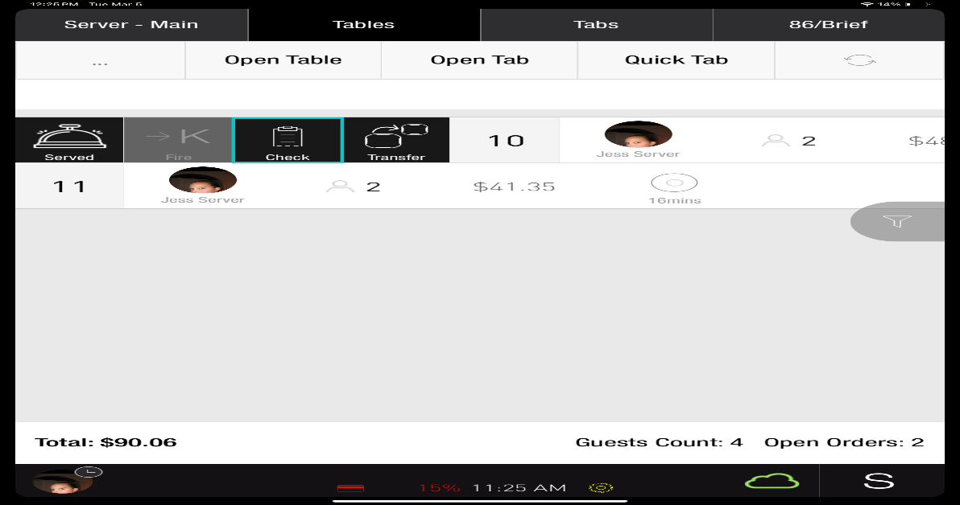](https://support-us.tabit.cloud/hc/article_attachments/17627044710034)

1. The check will now print

[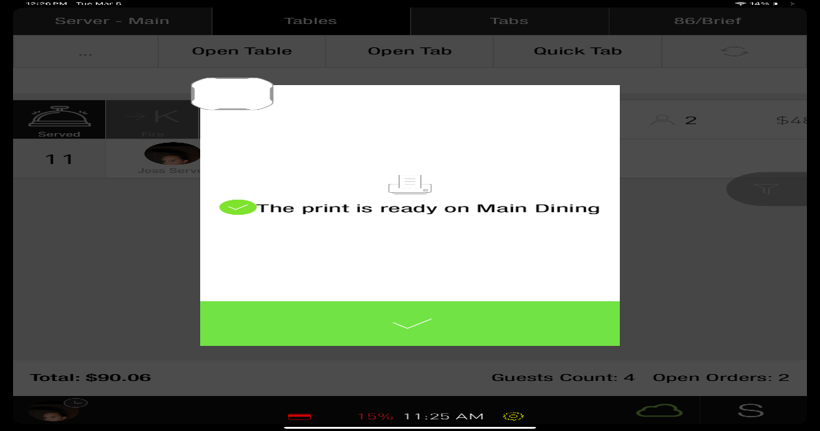](https://support-us.tabit.cloud/hc/article_attachments/17627044727058)

***If you need further assistance, please call Flyght Support at 419-724-3115 or send us an email:*** [***support@whatisflyght.com***](mailto:support@whatisflyght.com)