How do I Mark a Table as Clean on the PAD?

Contents

**Reasons Why an Order Can Be Suspended** 3

**Procedure on How to Suspend an Order:** 3

Once an Order is paid for and closed, the Table will appear as dirty, indicated by a grey background.

When a Table is marked as dirty on the PAD, it is reflected in Tabit Guest as well. It's important to mark Tables as clean once they are cleaned so that the Host knows what Tables are ready to be sat

[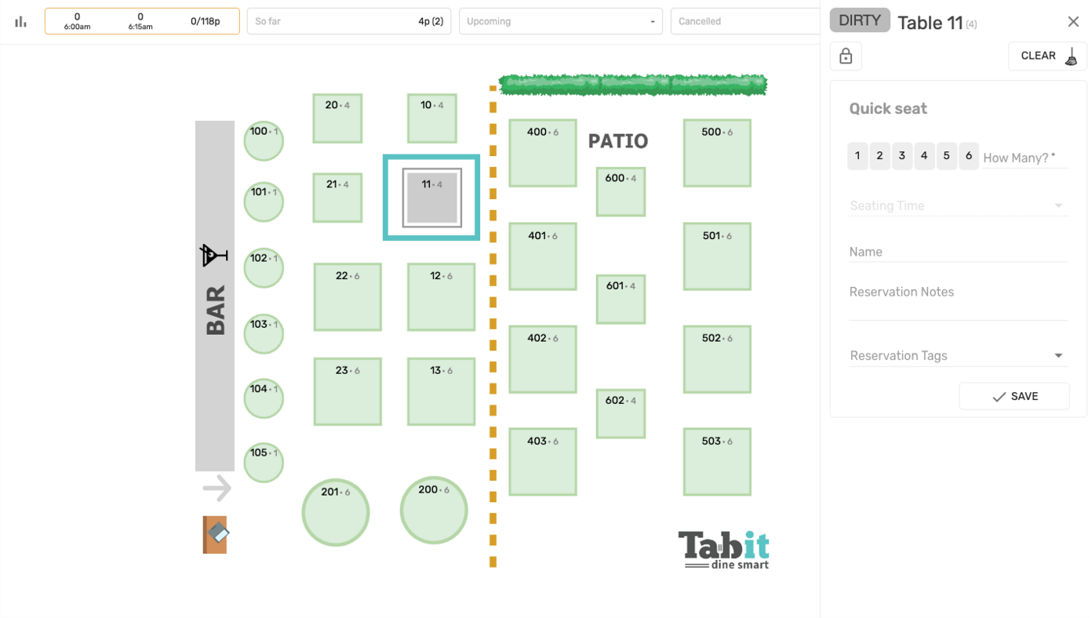](https://support-us.tabit.cloud/hc/article_attachments/13387894070034)

# Follow the steps below to learn how to mark a dirty table as clean:

1. To mark a table as clean on the PAD, long press on the dirty table

[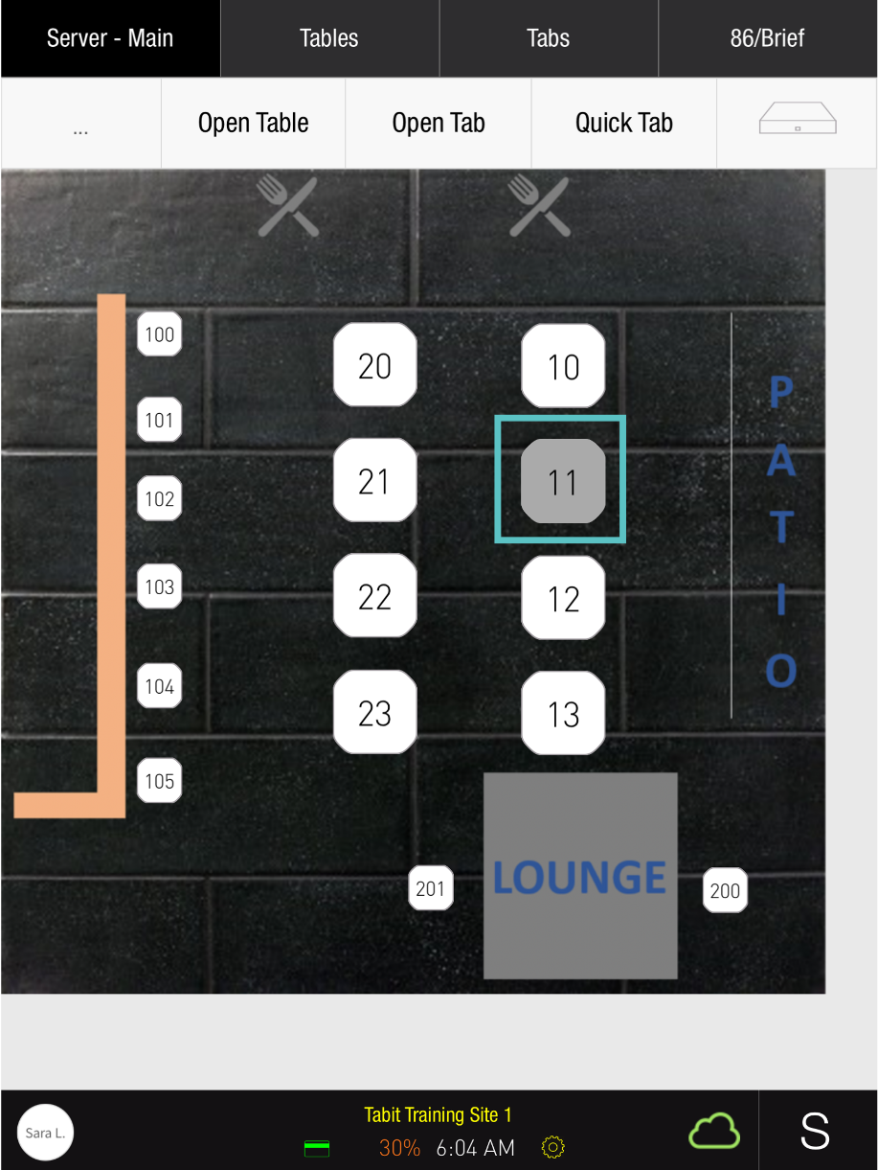](https://support-us.tabit.cloud/hc/article_attachments/13387894070930)

1. Tap **Clean Table**

[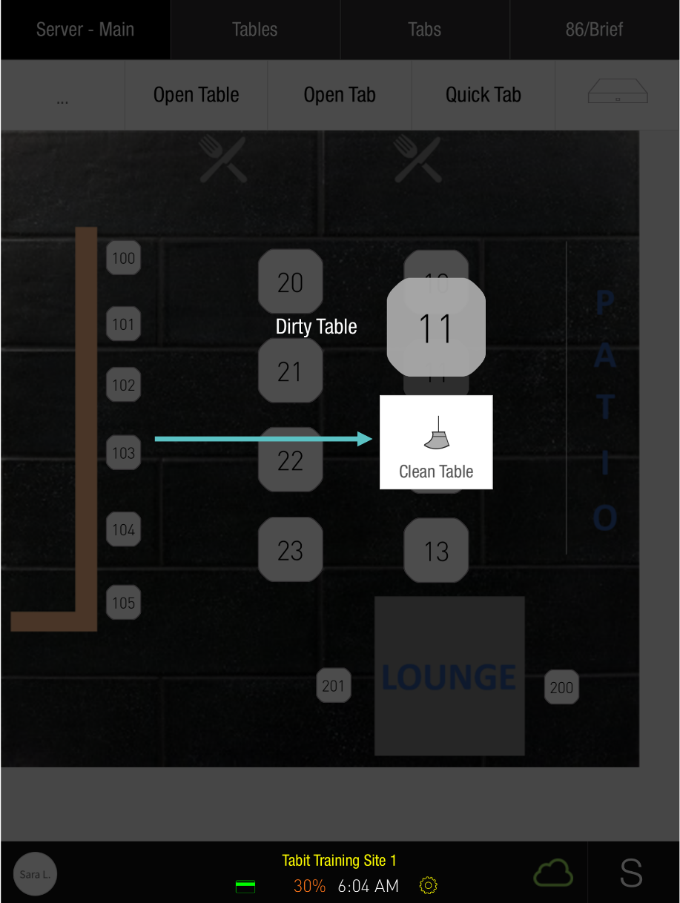](https://support-us.tabit.cloud/hc/article_attachments/13387918982674)

1. Now the Table has been marked as clean and will appear as available in Tabit Guest

[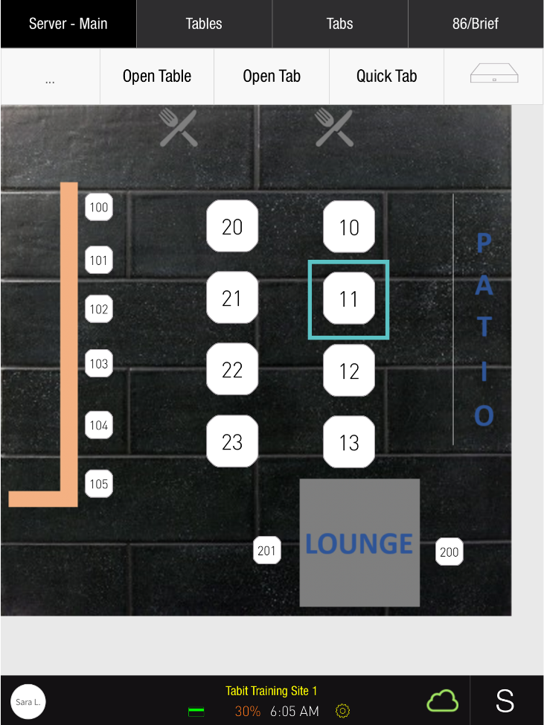](https://support-us.tabit.cloud/hc/article_attachments/13387894092434)

[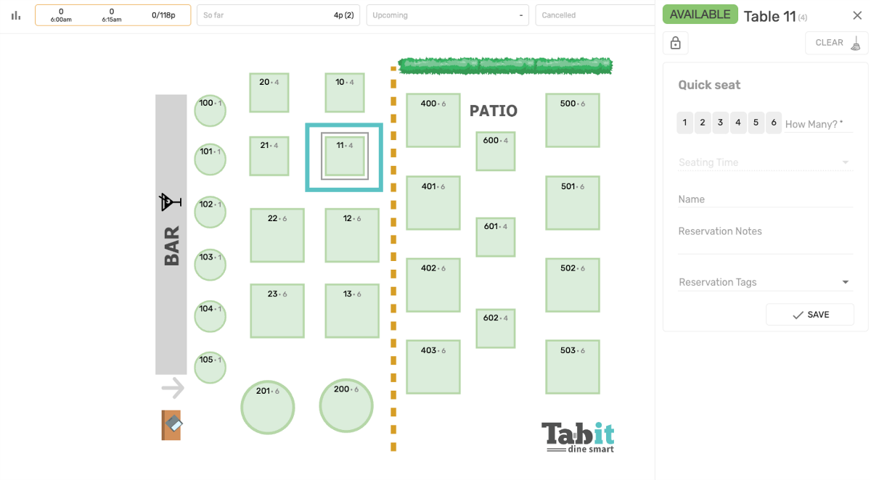](https://support-us.tabit.cloud/hc/article_attachments/13387894093970)

***If you need further assistance, please call Flyght Support at 419-724-3115 or send us an email:*** [***support@whatisflyght.com***](mailto:support@whatisflyght.com)