How to Transfer an Item to Another Table, Tab, or Guest

Contents

Follow the steps below to learn how to transfer an Item after it has been fired: 3

Transfer to a Table 5

Transfer to a Tab 8

Transfer to a Guest 11

Once an Item has been fired, it can only be transferred to another Table, Tab, or Guest from the Check Screen, and not from the Order Screen.

# Follow the steps below to learn how to transfer an Item after it has been fired:

1. From the Check Screen, swipe right on the Item you would like to transfer

[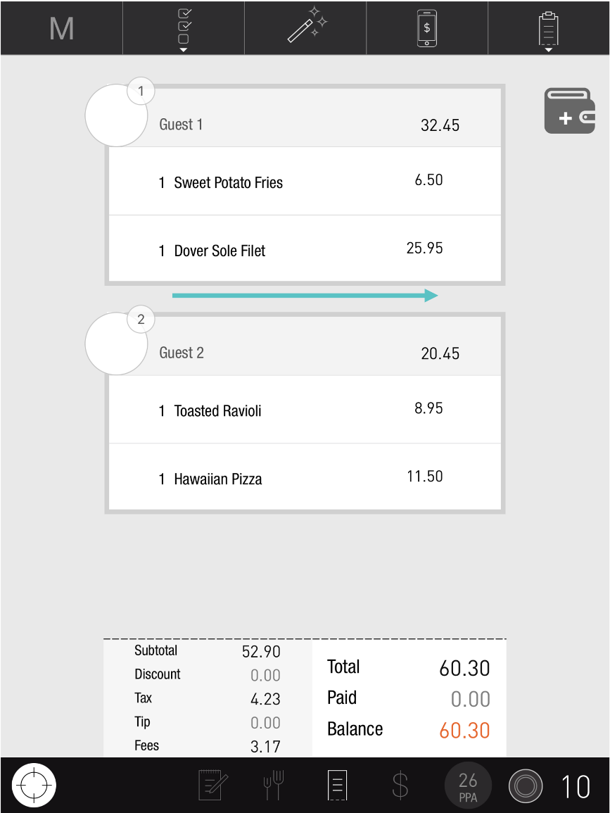](https://support-us.tabit.cloud/hc/article_attachments/13384027491346)

1. Select **Move To**

[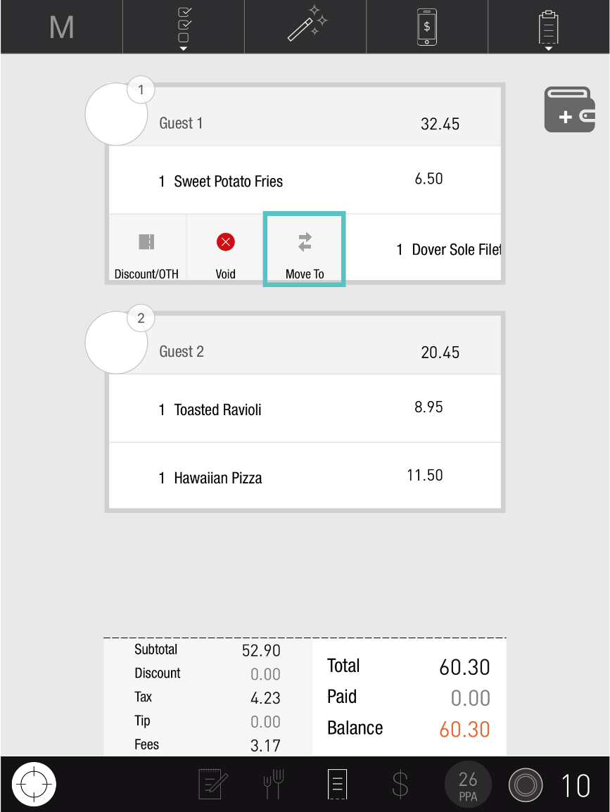](https://support-us.tabit.cloud/hc/article_attachments/13384049891730)

1. From here you have three options: transferring the Item to another Table, Tab, or Guest

# Transfer to a Table

1. To transfer the Item to another Table, enter the Table number

[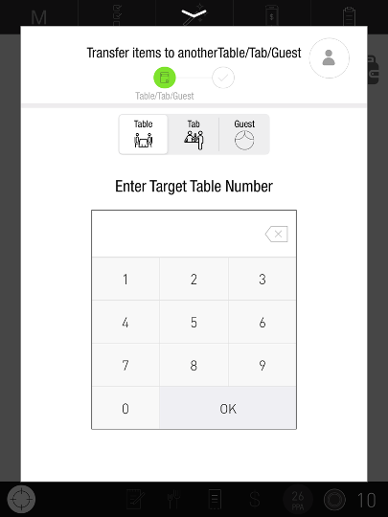](https://support-us.tabit.cloud/hc/article_attachments/13384049897234)

1. Tap**Submit**

[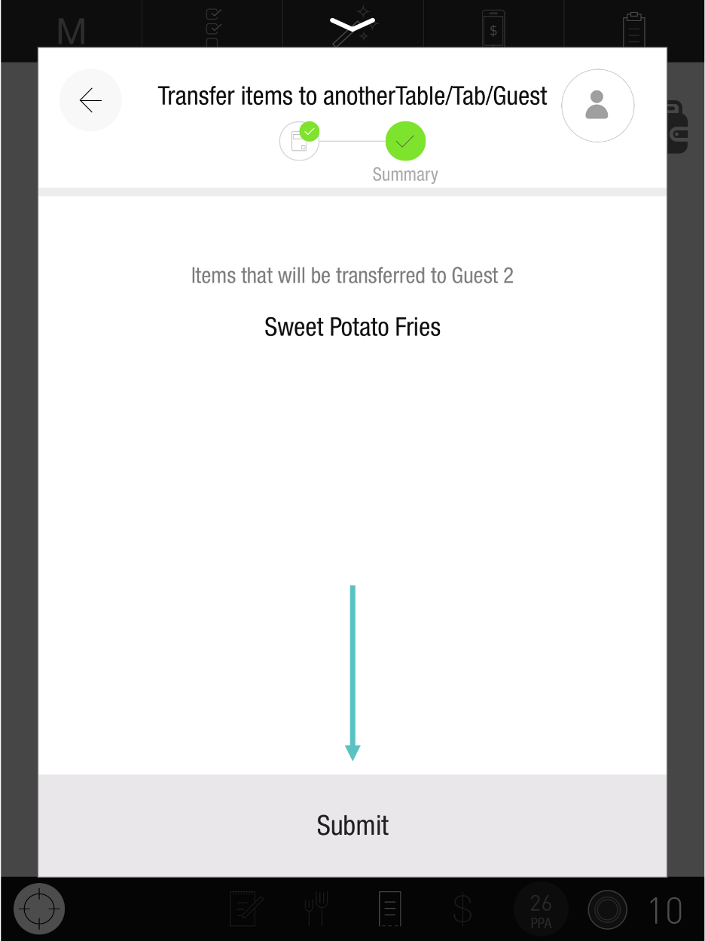](https://support-us.tabit.cloud/hc/article_attachments/13384027549074)

1. The Item has now been transferred to another Guest, and will have an indication showing which Guest it was transferred from

[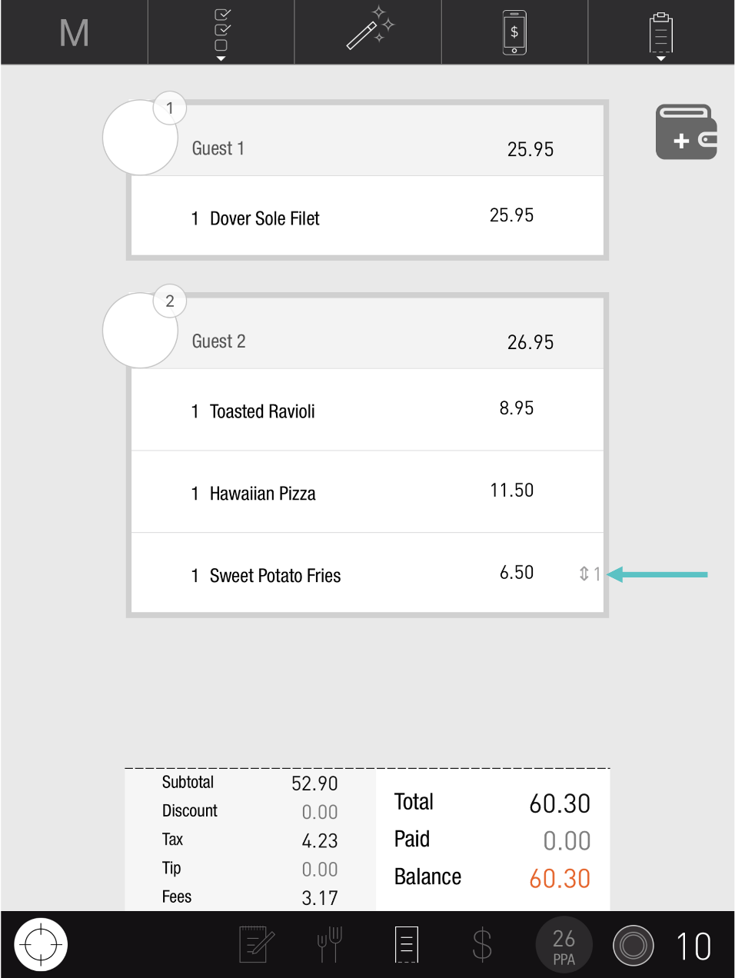](https://support-us.tabit.cloud/hc/article_attachments/13384049916562)

# Transfer to a Tab

1. To transfer the Item to a Tab, tap **Tab** and select the relevant Tab to transfer it to

[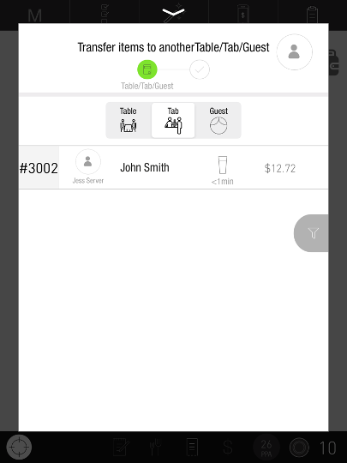](https://support-us.tabit.cloud/hc/article_attachments/13384049908498)

1. Tap**Submit**

[](https://support-us.tabit.cloud/hc/article_attachments/13384027549074)

1. The Item has now been transferred to another Guest, and will have an indication showing which Guest it was transferred from

[](https://support-us.tabit.cloud/hc/article_attachments/13384049916562)

# Transfer to a Guest

1. To transfer the Item to another Guest, tap **Guest** and select the relevant Guest to transfer it to

[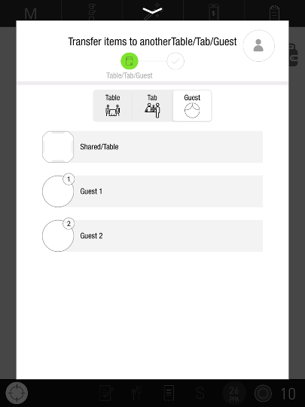](https://support-us.tabit.cloud/hc/article_attachments/13384049930770)

1. Tap**Submit**

[](https://support-us.tabit.cloud/hc/article_attachments/13384027549074)

1. The Item has now been transferred to another Guest, and will have an indication showing which Guest it was transferred from

[](https://support-us.tabit.cloud/hc/article_attachments/13384049916562)

***If you need further assistance, please call Flyght Support at 419-724-3115 or send us an email:*** [***support@whatisflyght.com***](mailto:support@whatisflyght.com)