Reprinting a Closed Check from a Server Profile

Contents

Follow these steps to reprint a Closed Check from a Server Profile 3

Follow these steps to reprint a Closed Check from a Server Profile
1. Tap on the ... located on the upper left-hand corner below the Map tab
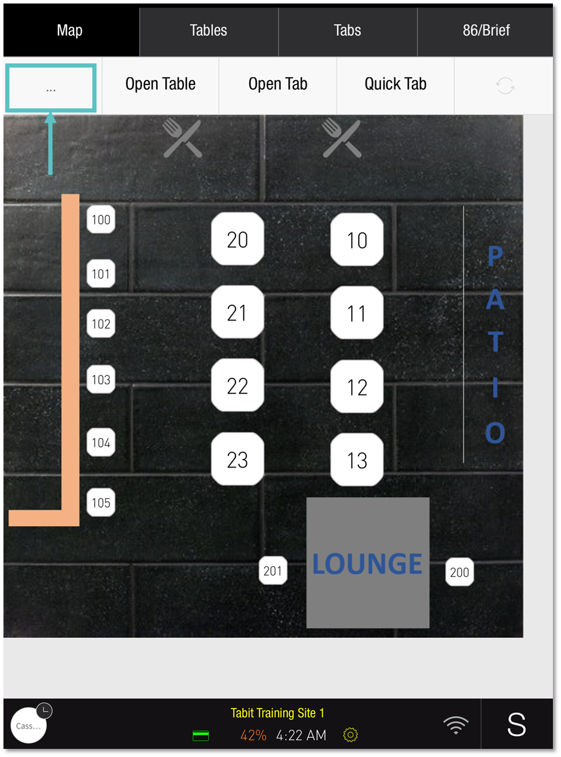

2. Tap Order Search
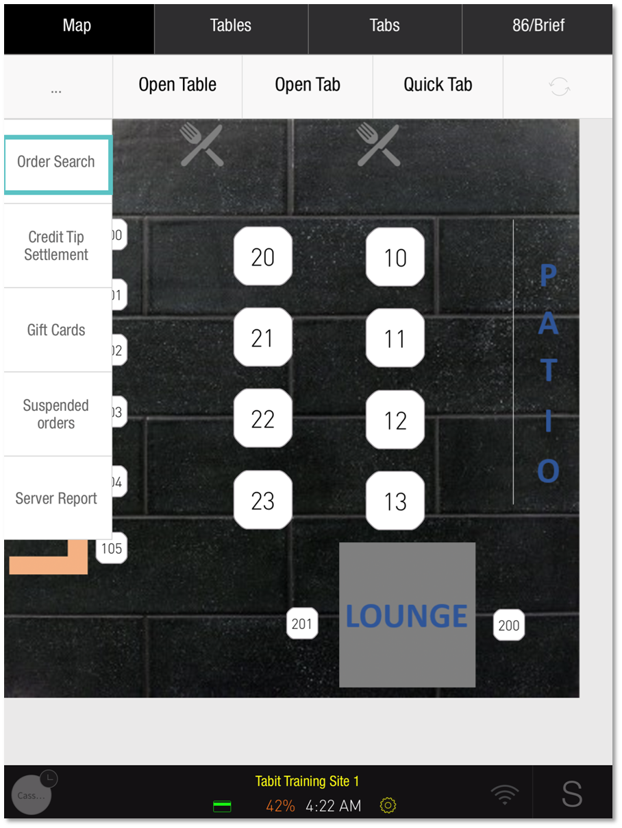

3. Search for the Order by Date or Type, or use the Advanced Search to find it using other Order details
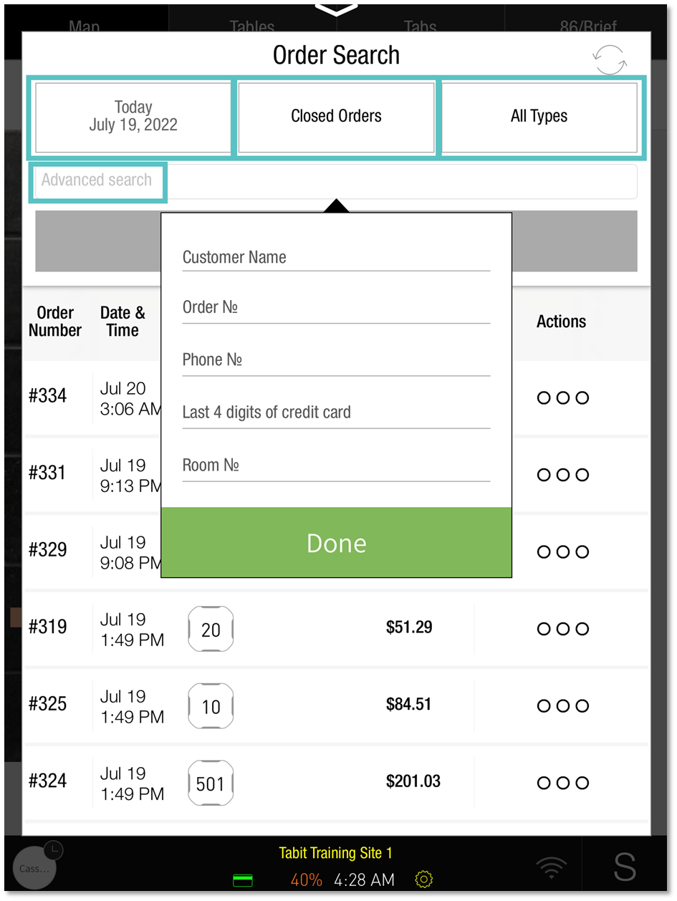

4. Tap the Three dots to the right of the relevant Order
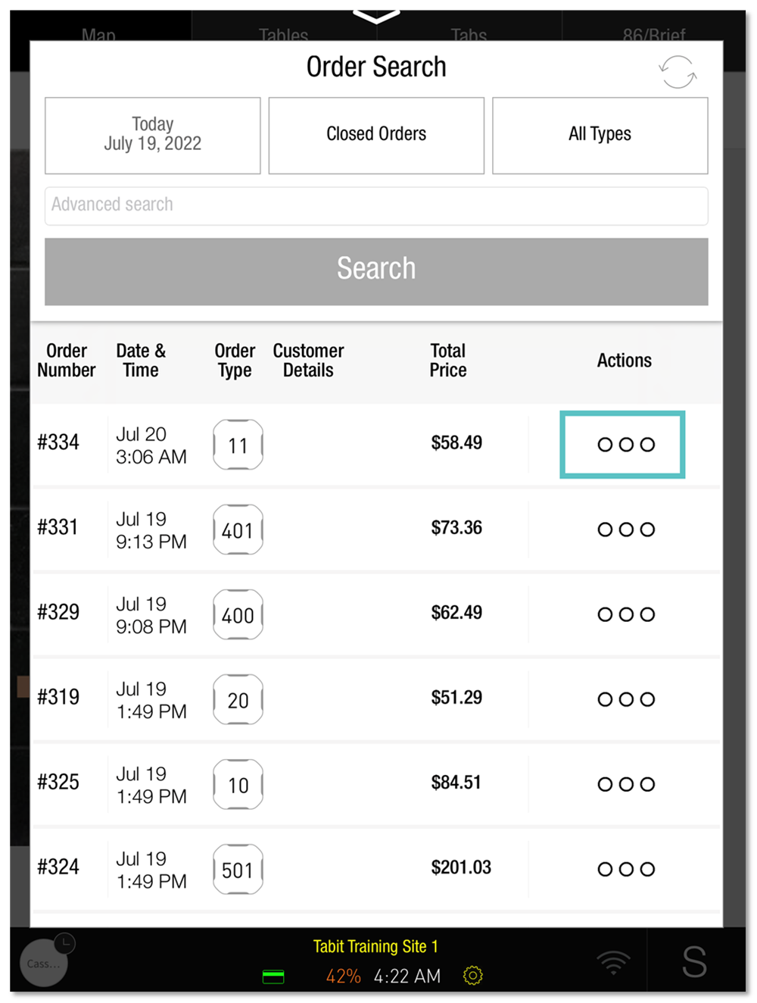

5. Tap Print Bill and select a printer
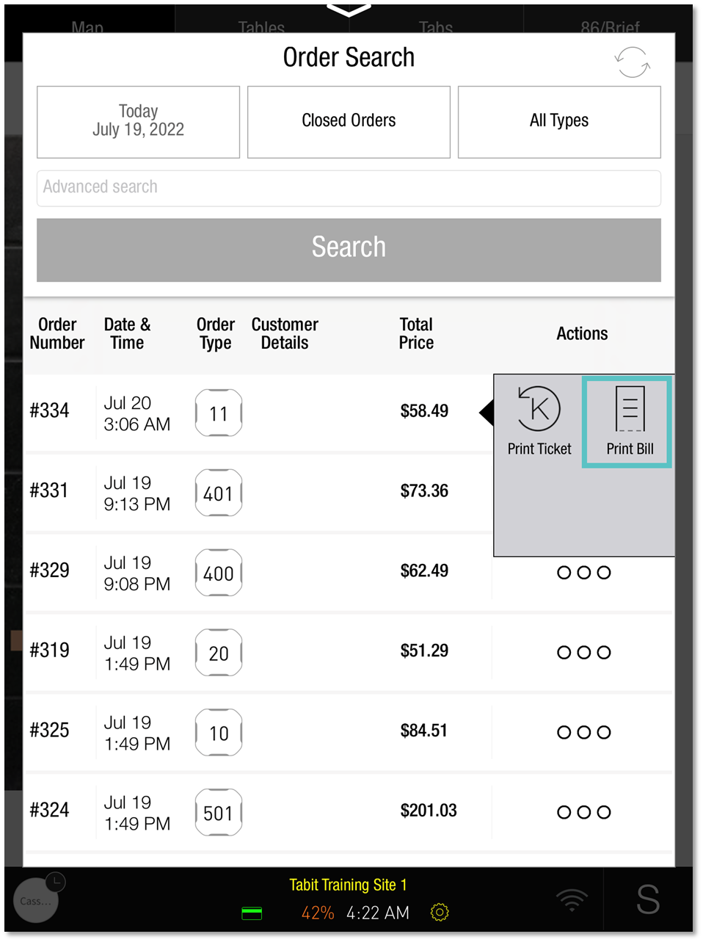

If you need further assistance, please call Flyght Support at 419-724-3115 or send us an email: support@whatisflyght.com

