How to Activate or Deactivate

an Existing Promotion

Contents

Procedure on How to Activate or Deactivate an Existing Promo 3

# Procedure on How to Activate or Deactivate an Existing Promo

1. Log into[**Tabit Office**](https://us-office.tabit.cloud/auth/login)
2. Go to **Promotions** > **Promotions**
3. Select an existing promo from the list and click **Edit  
     
   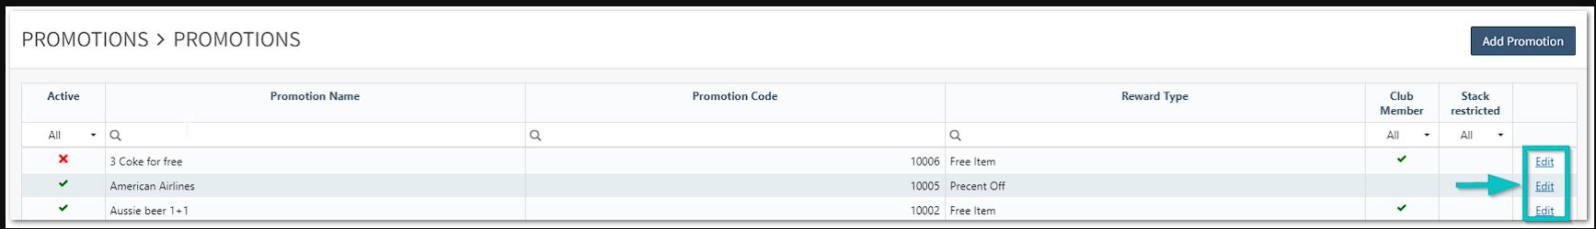**
4. Select to “Activate” or “Deactivate”  
     
   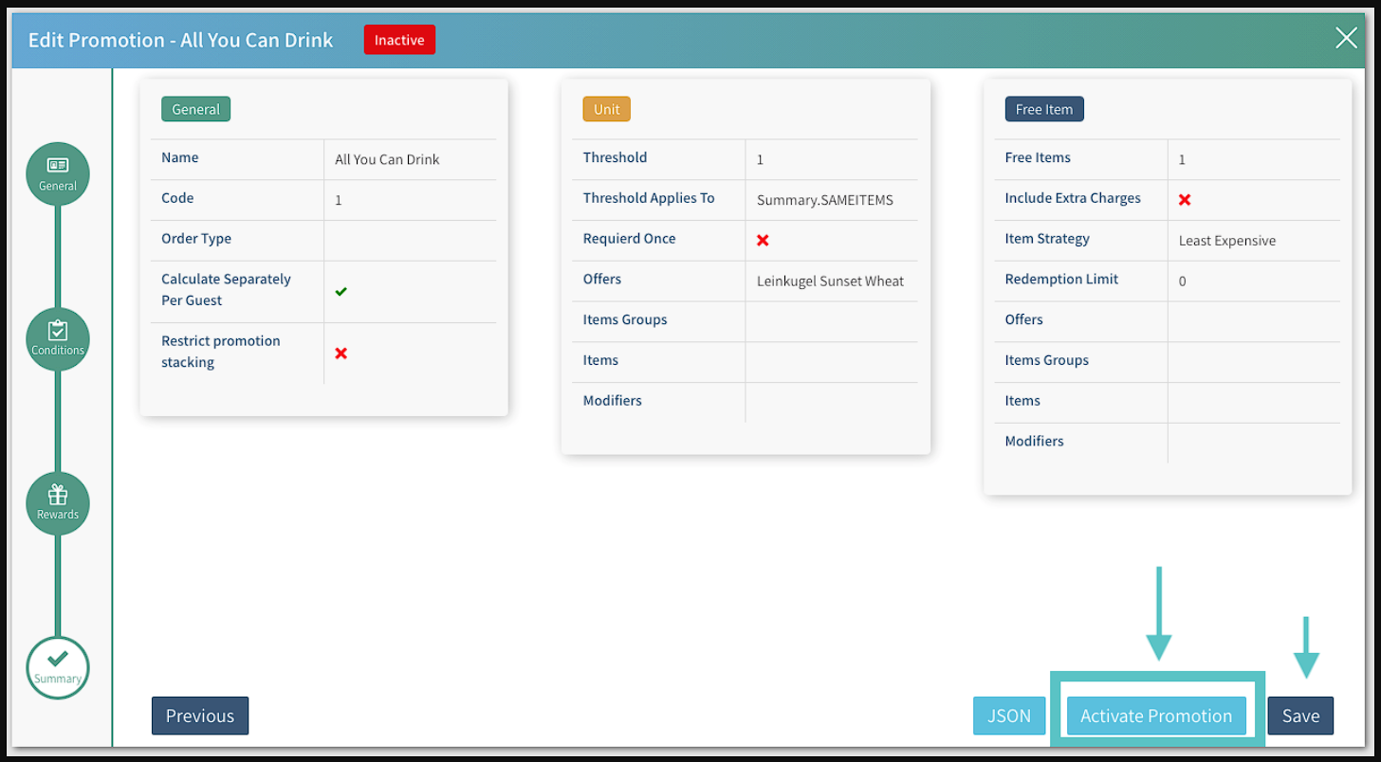  
     
   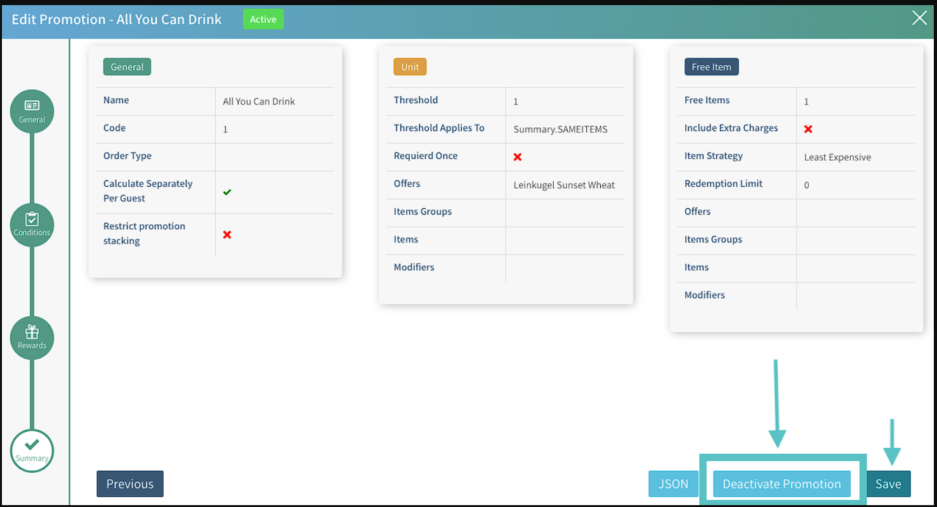
5. Save

**Promotion status view:**

**Green** = Active | **Red** = Inactive  
 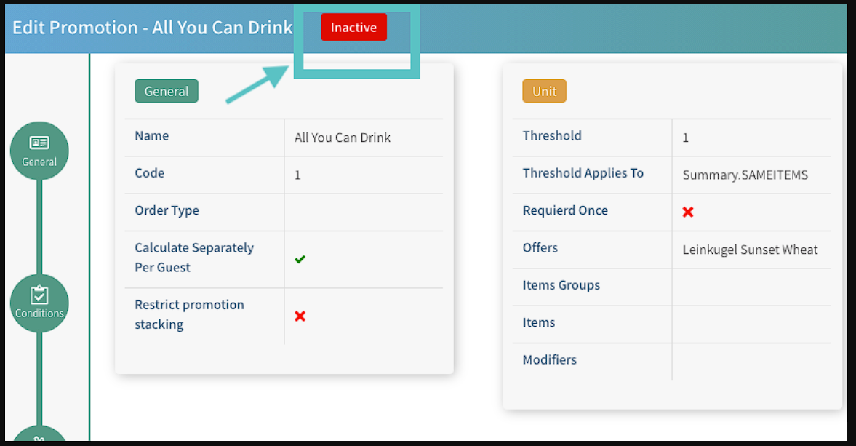

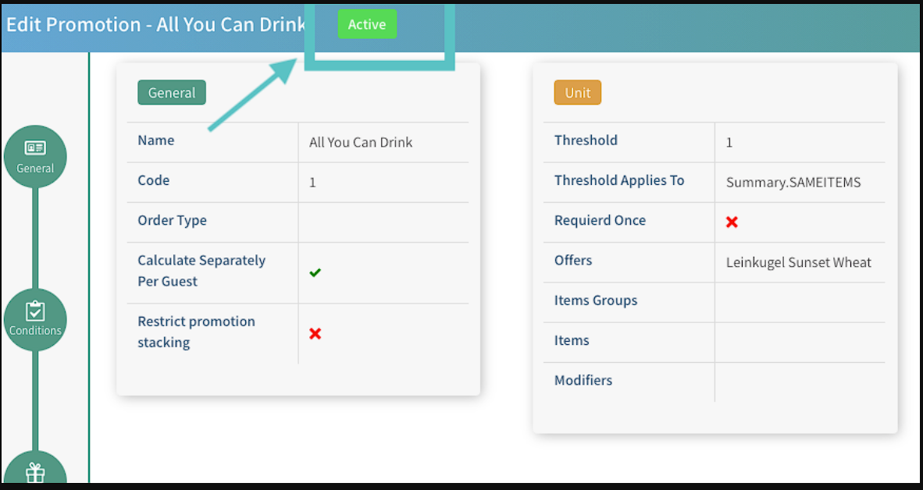

📢**Please Note:**

1. In case the PAD did not take the changes, try logging out, long pressing on "Refresh all data", and waiting until the 3 dancing dots appear on your screen.
2. Log back in and test.

***If you need further assistance, please call Flyght Support at 419-724-3115 or send us an email:*** [***support@whatisflyght.com***](mailto:support@whatisflyght.com)