How to Search for an Item on the PAD

Contents

Follow the steps below to learn how to search for an Item on the PAD: 3

Sometimes, it may be quicker to simply search for an Item when taking an Order than to find it by looking through the Menu.

# Follow the steps below to learn how to search for an Item on the PAD:

1. On the Order screen, tap the Search icon in the bottom right of the screen

[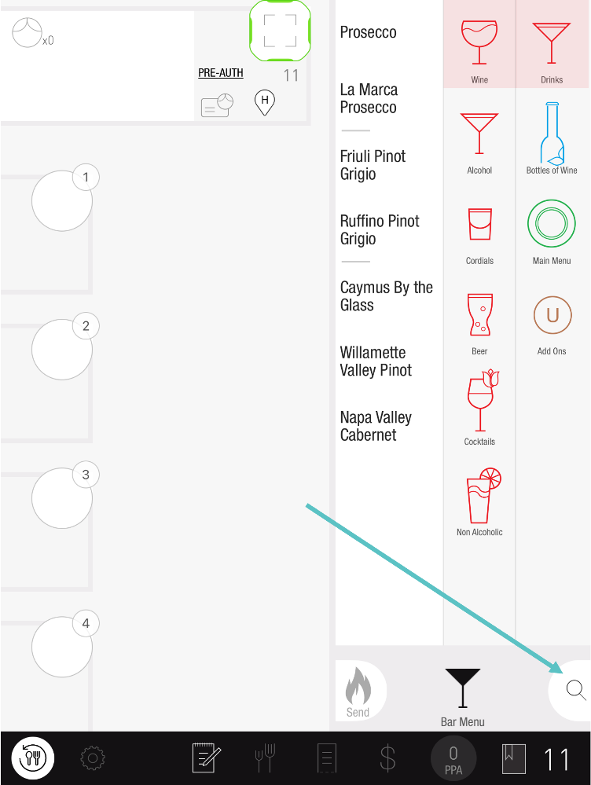](https://support-us.tabit.cloud/hc/article_attachments/13646140649362)

1. Enter the name of the Item into the **Search Item** section. The dynamic search will pull up the Item as you enter its name

 Only Items that have been published to PAD View will be able to be searched

[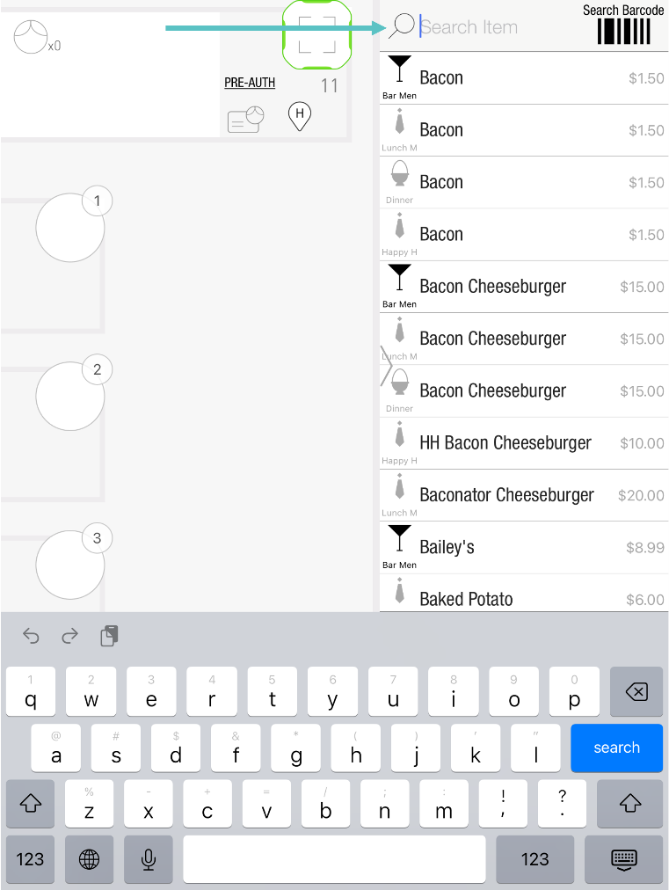](https://support-us.tabit.cloud/hc/article_attachments/13646186415890)

1. Drag the Item to the seat, swipe right to exit the search screen, and continue the Order as usual

 If the Item appears on more than one Menu, the current Menu will appear in black and others will be gray

[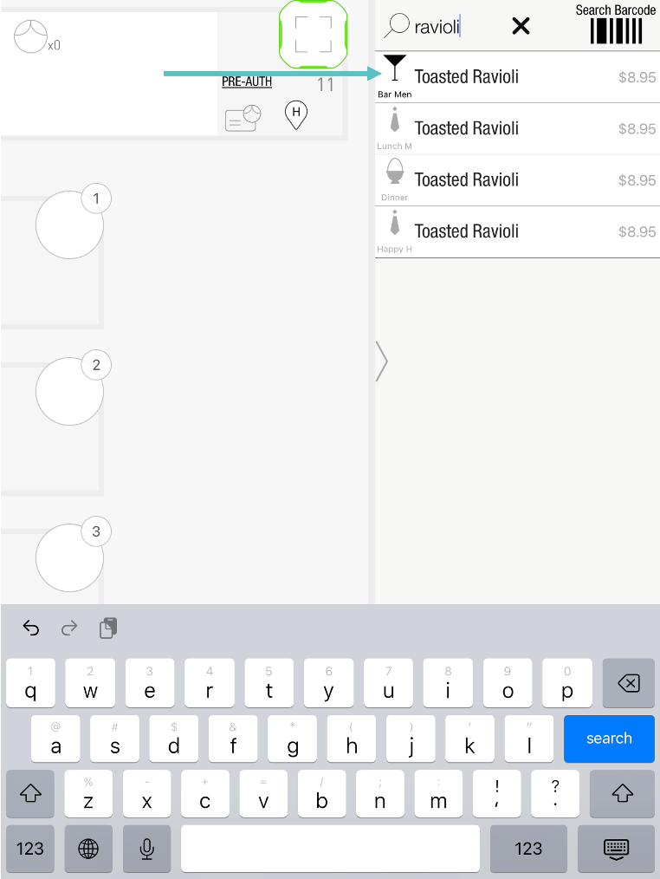](https://support-us.tabit.cloud/hc/article_attachments/13646140671378)

***If you need further assistance, please call Flyght Support at 419-724-3115 or send us an email:*** [***support@whatisflyght.com***](mailto:support@whatisflyght.com)