How to Re-order Drinks

Contents

Follow the steps below to learn how to re-order another round of drinks from the PAD 3

# Follow the steps below to learn how to re-order another round of drinks from the PAD

1. From the Order screen, tap on the **Spoon** **and** **Fork** icon at the bottom left of the screen

[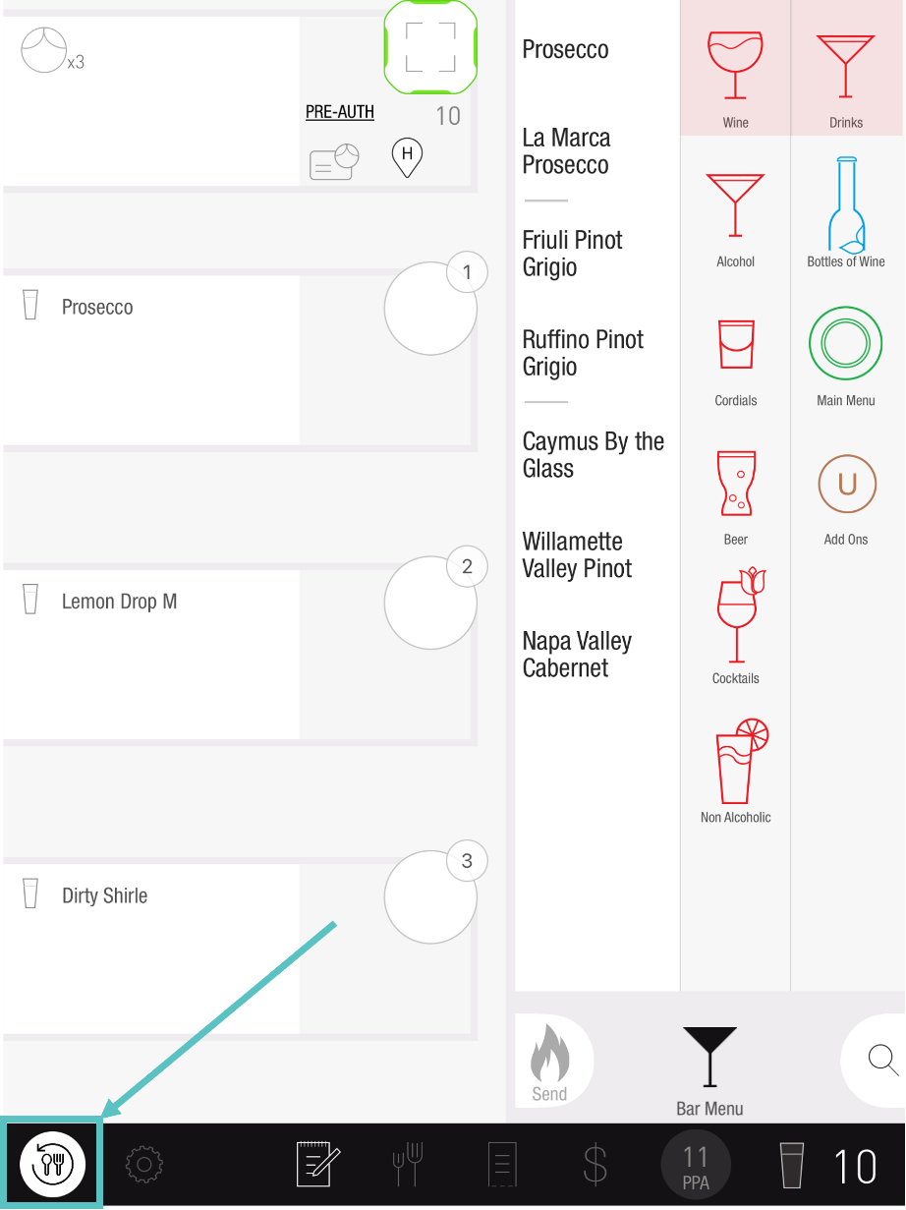](https://support-us.tabit.cloud/hc/article_attachments/13389097247890)

1. Select which Items to re-order, or tap the button on the same line as the course icon. This will automatically select all

[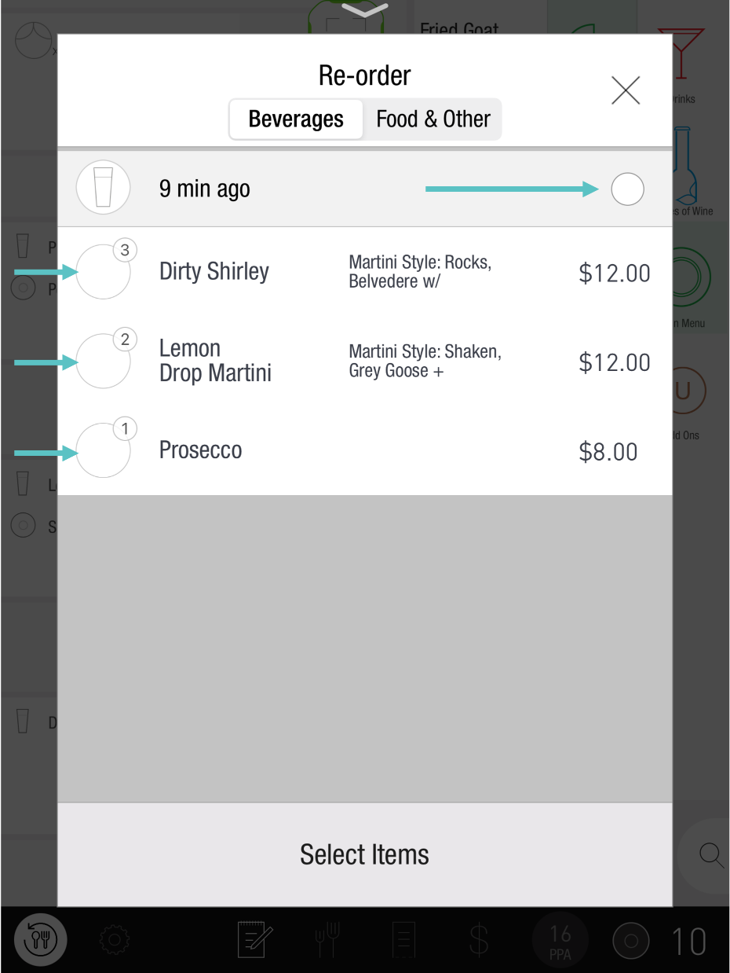](https://support-us.tabit.cloud/hc/article_attachments/13389100674962)

1. Swipe left to fire the Order

[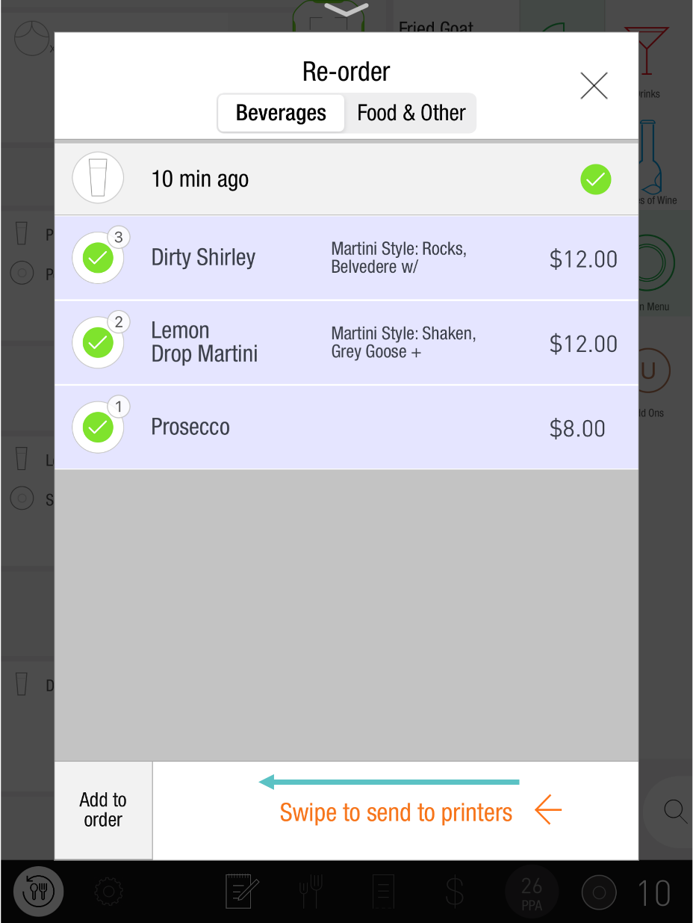](https://support-us.tabit.cloud/hc/article_attachments/13389114040466)

***If you need further assistance, please call Flyght Support at 419-724-3115 or send us an email:*** [***support@whatisflyght.com***](mailto:support@whatisflyght.com)