Editing a Course from the Order Screen

Contents

Follow the steps below to learn how to edit a Course from the Order Screen on the PAD: 3

Courses can be edited from the Order Screen to change the pace of Items as needed. For example, if a customer would like both their appetizers and entrees to come out together, the course can easily be edited through the Item itself.

**This is only relevant for restaurants working with coursing**

**Coursing can only be edited before Items are sent to the kitchen**

# Follow the steps below to learn how to edit a Course from the Order Screen on the PAD:

1. From the **Order** **Screen**, long press on the relevant **Item**

[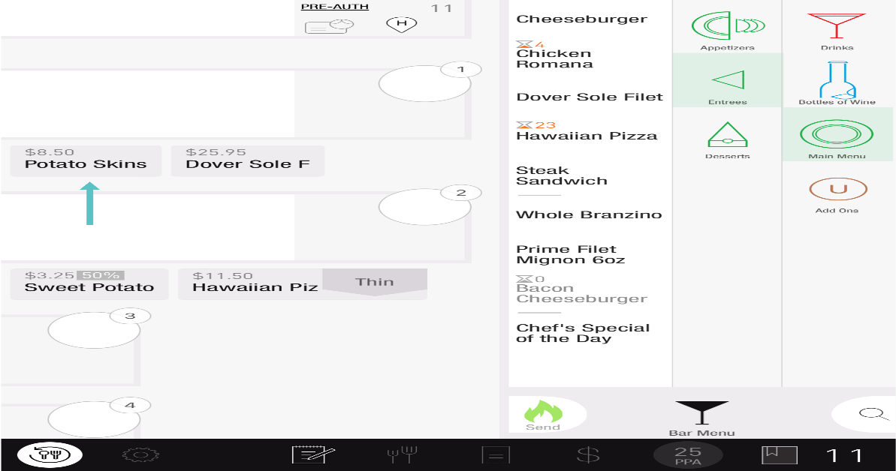](https://support-us.tabit.cloud/hc/article_attachments/15991705937682)

1. Select the **Course** you would like to move it to

[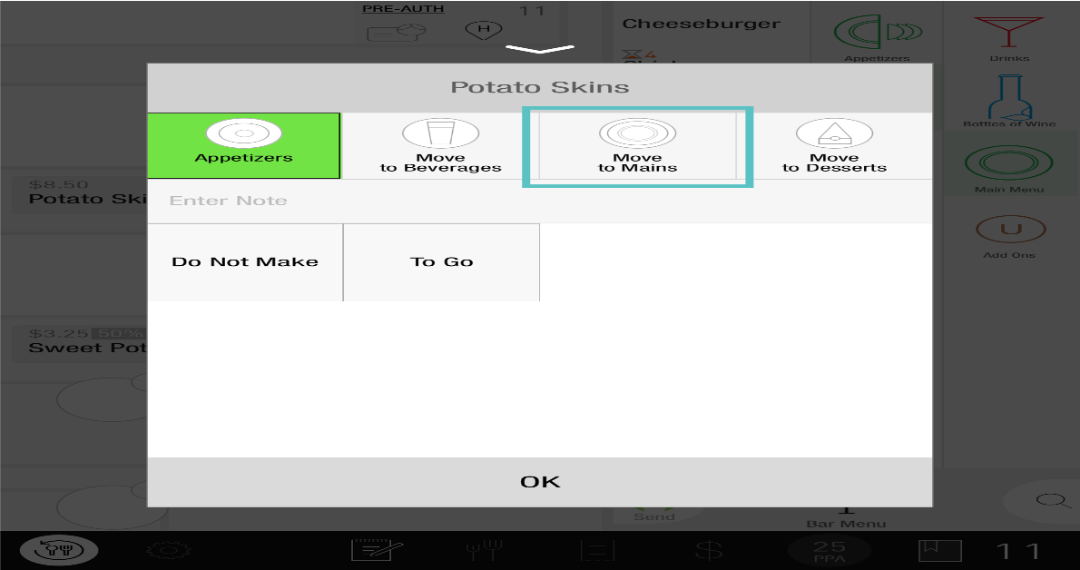](https://support-us.tabit.cloud/hc/article_attachments/15991705942418)

1. Select **OK**

[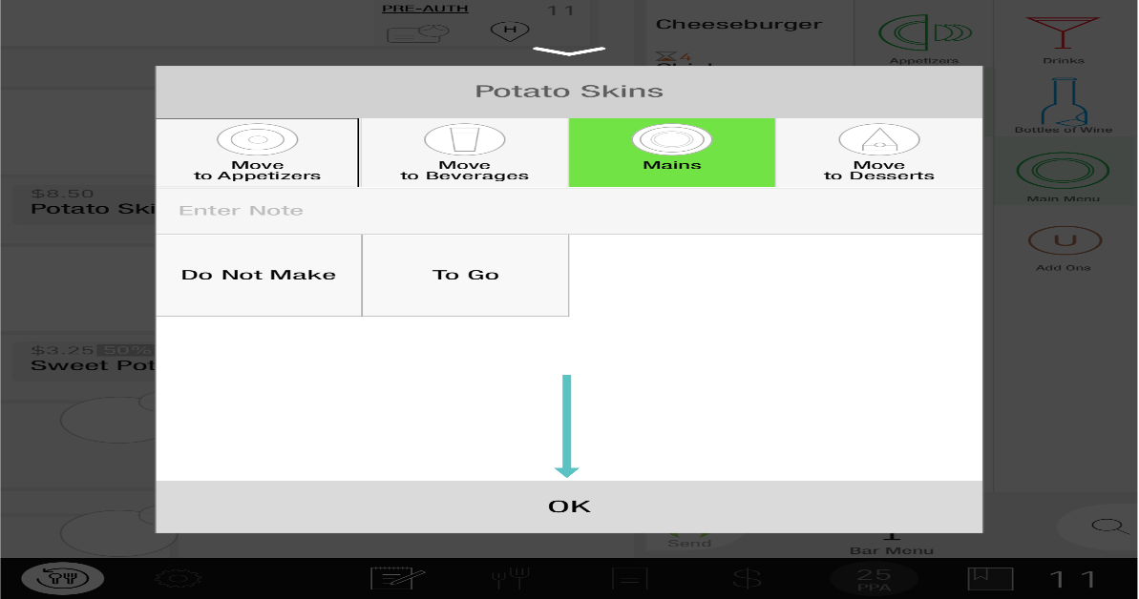](https://support-us.tabit.cloud/hc/article_attachments/15991714817682)

1. Now the Item has been moved to the desired Course

If you would like to confirm that it's been moved to the correct Course, tap on the **Coursing Screen**

[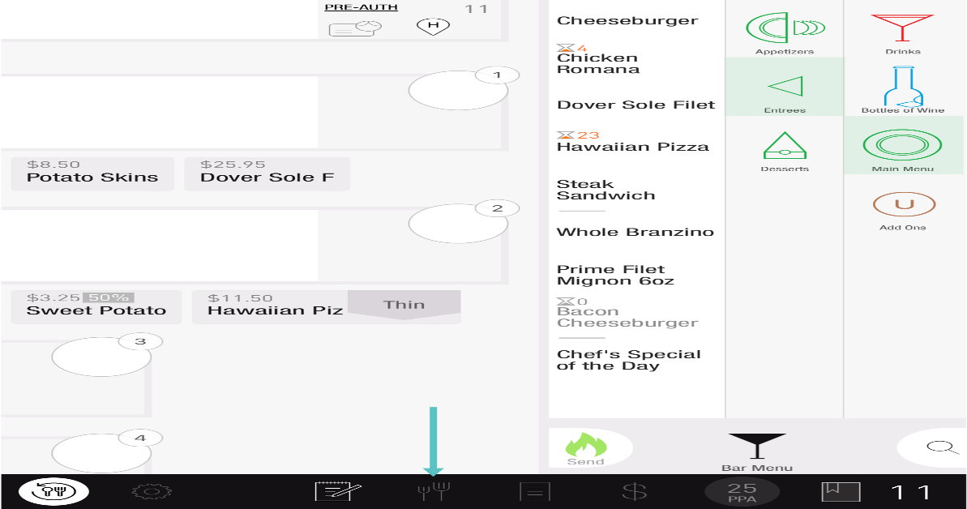](https://support-us.tabit.cloud/hc/article_attachments/15991714818962)

From here, you can see each Item and their assigned Course

[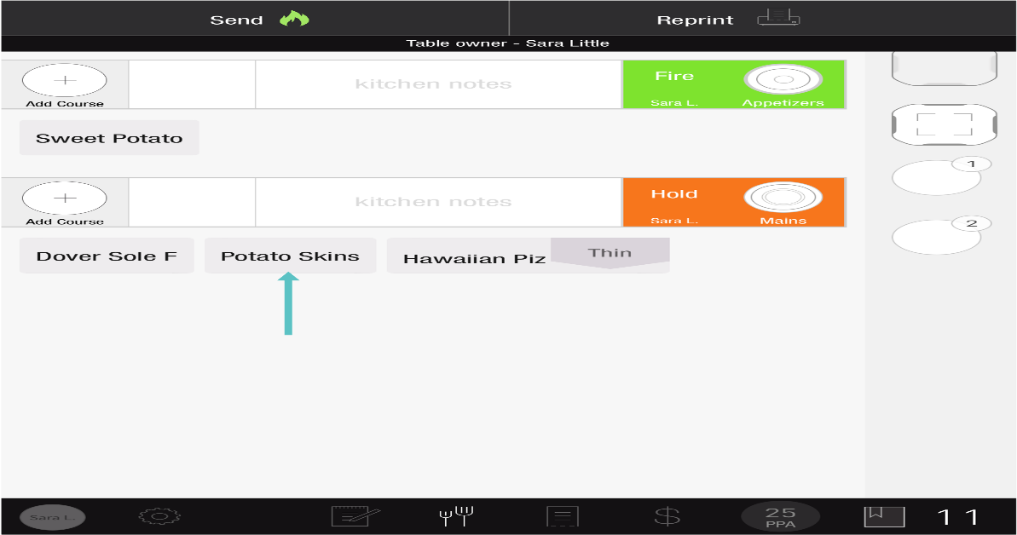](https://support-us.tabit.cloud/hc/article_attachments/15991705955090)

***If you need further assistance, please call Flyght Support at 419-724-3115 or send us an email:*** [***support@whatisflyght.com***](mailto:support@whatisflyght.com)