How to Create a Promotion in Tabit Order

Contents

Adding a Promotion in Tabit Order 3
Requirement: 3
Steps on How to Create a Promotion in Tabit Order 3

Adding a Promotion in Tabit Order

Requirement:
You need to have Manager access in Tabit Office to perform the following procedures.

Steps on How to Create a Promotion in Tabit Order
- Login to Tabit Office
- In Office, go to Customer Order > Site Setup. Select the Promotions tab and then select New Promotion
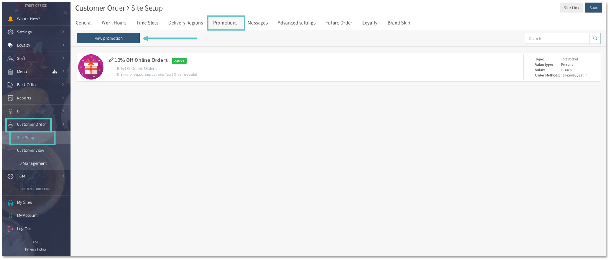
- Enter the required details and then select Save:
- Name: The title of the promotion
- Status: Determines whether the promotion is active or disabled
- Type: Select how the promotion is calculated
- Reason: Lists the predetermined options for how the comp will report
- Value Type: Whether the promotion is calculated based on a percent of the check total or a specific amount off
- Value: The numerical value for either the amount or the percentage amount for the promotion
- Order Timing: Determines when the promotion will be displayed based on Regular Orders and Future Orders
- Order Methods: Defines which Order Methods qualify for the promotion (ex. Eat-In, Takeaway)
- Scheduling: Refers to the menu timeframe the promotion will be available
- Min. Order Price: Sets a minimum amount the customer must spend to qualify for the promotion
- Customer Facing Title: The title of the promotion that the customer will see
- Customer Facing Message: The message for the promotion that the customer will see
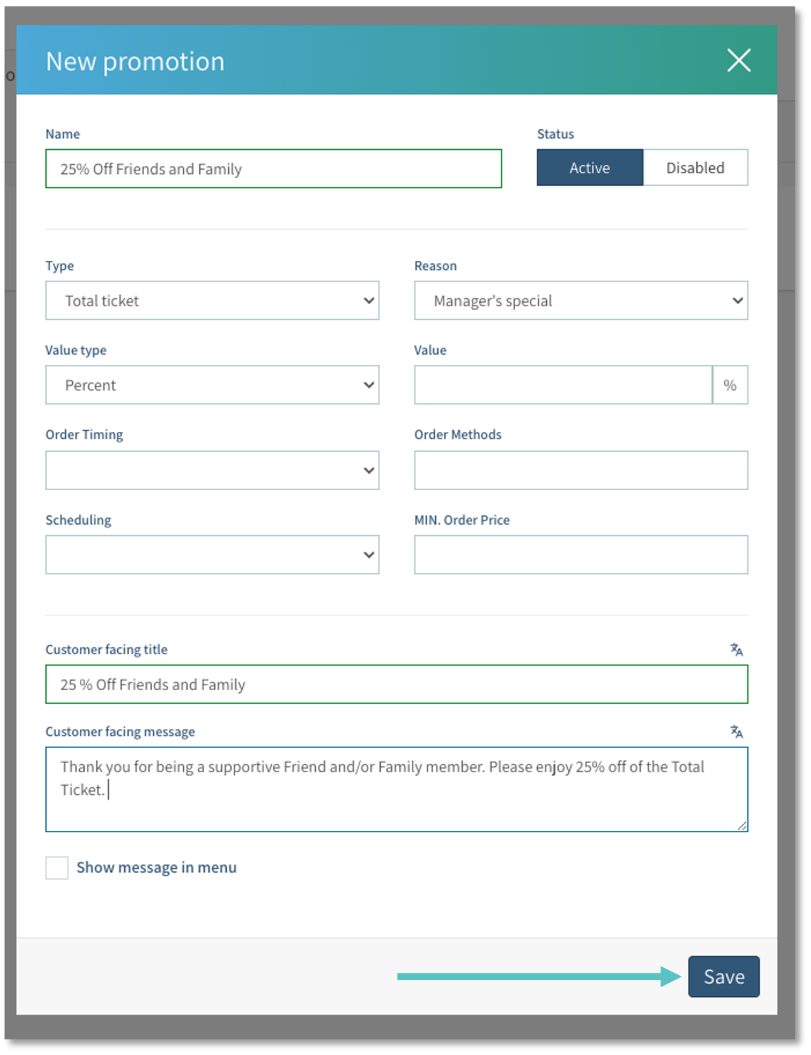
- Now the promotion will appear in Office
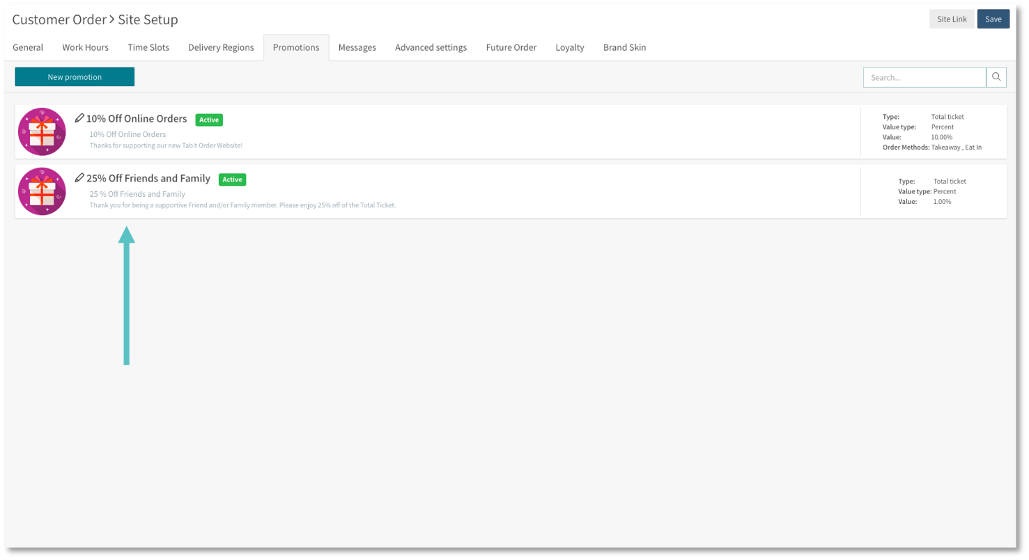
And in Tabit Order
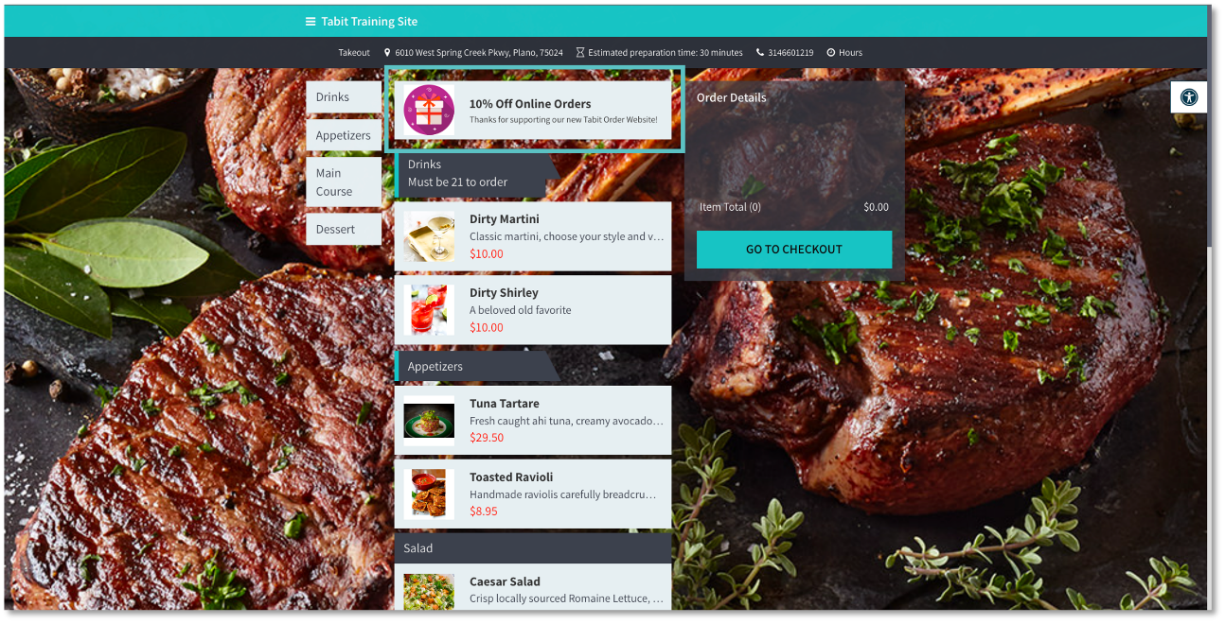
If you need further assistance, please call Flyght Support at 419-724-3115 or send us an email: support@whatisflyght.com

