Which One to Add:

A Text Decision or an Item Decision?

Contents

What is a Decision? 3

Best Practices for Adding Items to Decision Groups 3

Choosing Between Catalog Items or Free Text 4

Examples 4

# What is a Decision?

A **decision** is when you ask the customer to choose something (like selecting options from a list or entering text) before an item can be ordered. Sometimes, these choices are automatically pre-selected but can be changed. Other times, the customer must answer the question before proceeding.

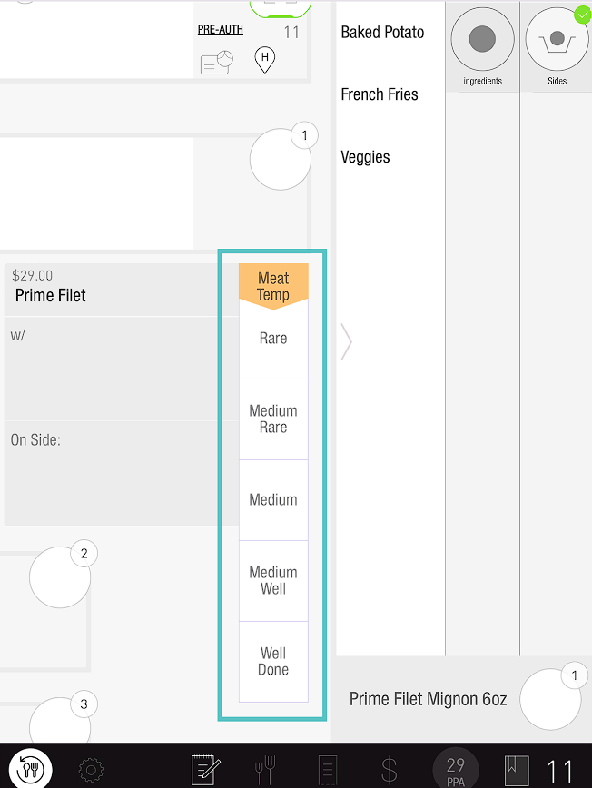

## Best Practices for Adding Items to Decision Groups

* **Always add items to the catalog**: This helps track sales and manage stock levels. It also avoids the need to reconfigure things later.
* **Difference from Modifier Groups**: Unlike a modifier group, items in a decision group **cannot have prices** (so no upcharges or add-ons). If you need to charge more for an item, create a modifier group instead.

## Choosing Between Catalog Items or Free Text

When setting up a decision, you can choose between using a catalog item or free text. Here's how to decide:

* **Use a catalog item** if:
  + You need to track sales.
  + You need to manage inventory and limit stock.
* **Use free text** if:
  + The decision doesn’t need to be tracked or limited.

## Examples

* **Meat temperature**: This typically doesn't need to be tracked, so free text works.
* **Salad dressings**: These often need tracking in inventory, so use catalog items.

***If you need further assistance, please call Flyght Support at 419-724-3115 or send us an email:*** [***support@whatisflyght.com***](mailto:support@whatisflyght.com)