How to Install a New

Ingenico Moby5500 Device

Contents

Office Setup 3

PAD Setup 3

Pairing the New Device 4

Before you begin, make sure the device is set up in Tabit Office.

# Office Setup

1. Log into Tabit Office with a [**Support Login**](https://flyght.atlassian.net/wiki/spaces/THCD/pages/246022186/Contact+Us).
2. Navigate to **Support > Payment Device Settings > Add**.  
   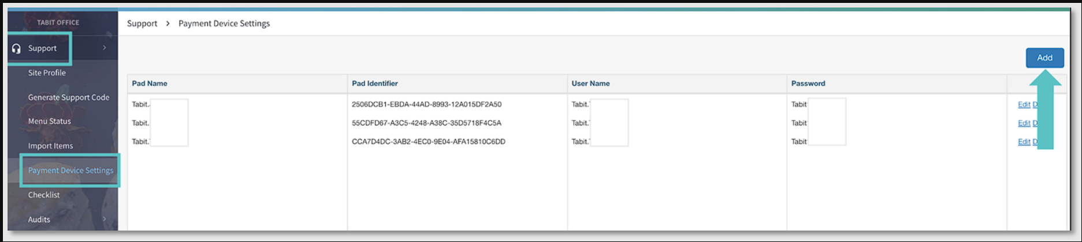
3. Find the **PAD Name**.
4. Enter your **Username and Password**.
5. Click **Save**.

# PAD Setup

**Note**: If you're replacing an old device, you might need to complete the following step first:

* On the PAD, go to **Settings > Bluetooth**. Find the old Moby5500 device and select **Forget Device**.  
    
  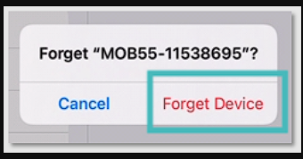

# Pairing the New Device

1. Turn on the Ingenico Moby5500 device (you should see a blinking blue and red light).
2. Log into the PAD with a **Manager Login** and go to **Operations > Technician > Ingenico Device Handler**.
3. Ensure the Ingenico user is logged in with the same credentials you used in Tabit Office.
4. Select **Pair** and choose the Moby5500 **device** from the list (the device name usually starts with "MOB55-").  
     
   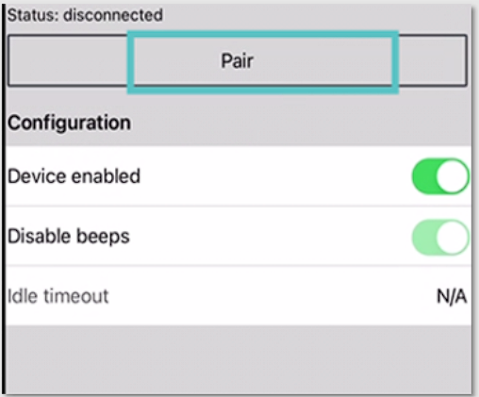
5. A pop-up will appear asking to pair the device—select **Pair**.  
     
   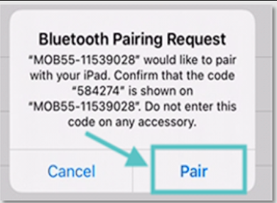
6. Within 5 seconds, press and release the power button on the Ingenico device. This will trigger a light pattern on the PAD.
7. The same pattern will also flash on the front of the Ingenico device. Wait until the light pattern disappears.
8. Confirm the pattern on the PAD by selecting **Confirm** if they match.  
     
   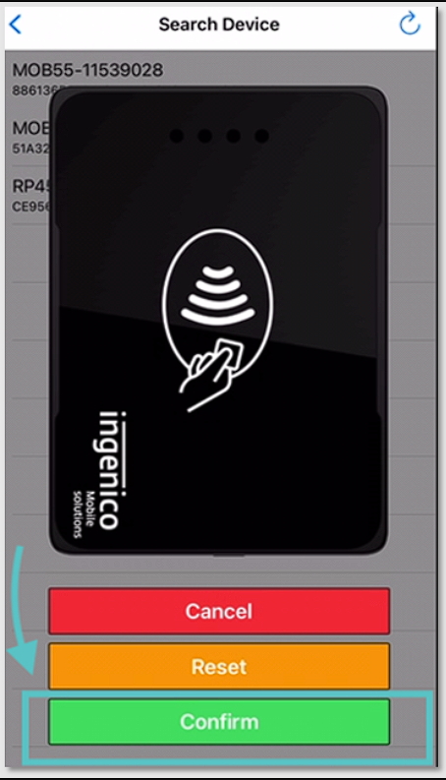
9. When the setup is done, the blue ribbon on the PAD will display **Insert/Tap/Swipe** as the entry modes.

Your Ingenico Moby5500 device is now ready to use!

***If you need further assistance, please call Flyght Support at 419-724-3115 or send us an email:*** [***support@whatisflyght.com***](mailto:support@whatisflyght.com)