How to Fix Ingenico Message:

"Payment Device Is Not Configured,

Please Contact the Manager"

Contents

Issue: Ingenico Device Connection Error on Login 3

Step-by-Step Fix 4

If the Issue Persists, Try the Following: 5

# Issue: Ingenico Device Connection Error on Login

You may see an error message when logging in, indicating that the Ingenico device cannot communicate with the PAD. Follow the steps below to resolve the issue:  
  
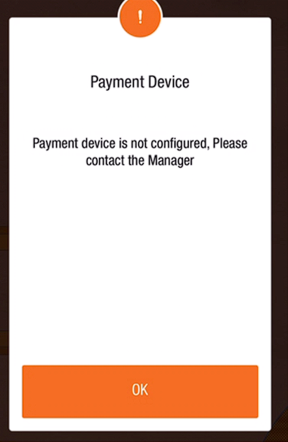

## Step-by-Step Fix

1. **Check Power**: Ensure the Ingenico device is charged and powered on.
2. **Power Cycle the Device**:
   * If the device is on, turn it off for 5-10 seconds.
   * Hold the power button for 3-5 seconds until all lights turn off.
3. **Turn it Back On**: You should see a blinking blue light and a solid red light once powered on.
4. **Restart the Tabit App**:
   * On the PAD, double-tap the home (round) button and swipe up on the Tabit rOS app to close it.

**Note**: This step won’t work with Spooler PADs. For Spooler PADs, refer to the article: How to Restart the Tabit Application on the Spooler (SPLR) PAD.

1. **Relaunch Tabit OS**: Open the app again and see if the error message is gone.
2. **Test the Device**: Ensure the device can now process credit cards.

## If the Issue Persists, Try the Following:

1. **Reboot the PAD**.
2. **Power Cycle the Ingenico Device Again**: Turn it off for 5-10 seconds and back on.
3. **Check Device Status**:
   * Log in with a Manager account.
   * Go to **Operation > Technician > Ingenico Device Handler**.  
     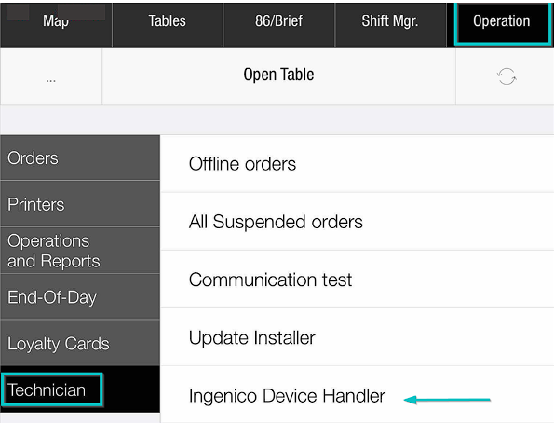
4. **Check the Status**:
   * If the device status shows **disconnected**, there should be an option to **Pair**.  
     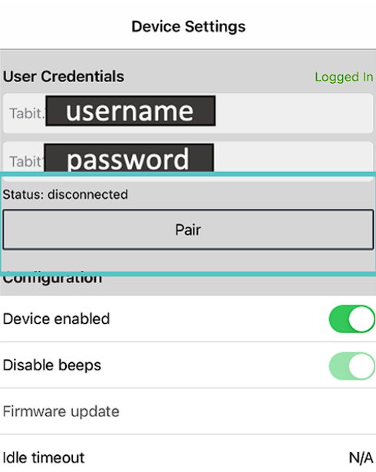
5. **Reconnect the Device**:
   * Turn off the Ingenico device again for 5-10 seconds, then power it back on.
   * The status should update to **connected** and a blue ribbon will appear at the bottom of the screen displaying the entry modes **Insert/Tap/Swipe**.  
       
     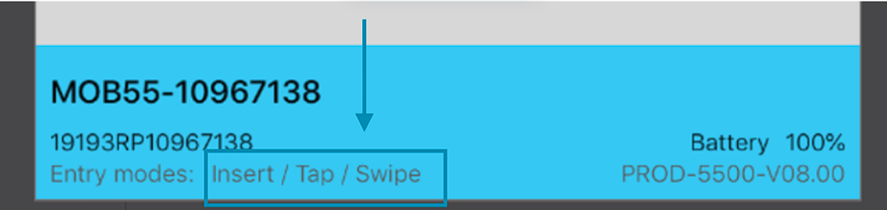

Your Ingenico device should now be connected and ready to use.

***If you need further assistance, please call Flyght Support at 419-724-3115 or send us an email:*** [***support@whatisflyght.com***](mailto:support@whatisflyght.com)