**How to Adjust Tips for Different Transactions**

Contents

[**Reasons Why an Order Can Be Suspended** 3](#_Toc170862039)

[**Procedure on How to Suspend an Order:** 3](#_Toc170862040)

## You may need to adjust tips in the following situations:

* **The guest didn’t tip on the PAD** and prefers to tip on a traditional credit card slip.
* **The restaurant uses offline payments** (only if the Ingenico device is offline).

:light_bulb_on:Note: Once a tip is settled, it can only be refunded partially or fully but cannot be adjusted again.

## For Servers:

1. Tap the "..." icon below the Map tab in the upper left-hand corner.
2. Select **Credit Tip Settlement**.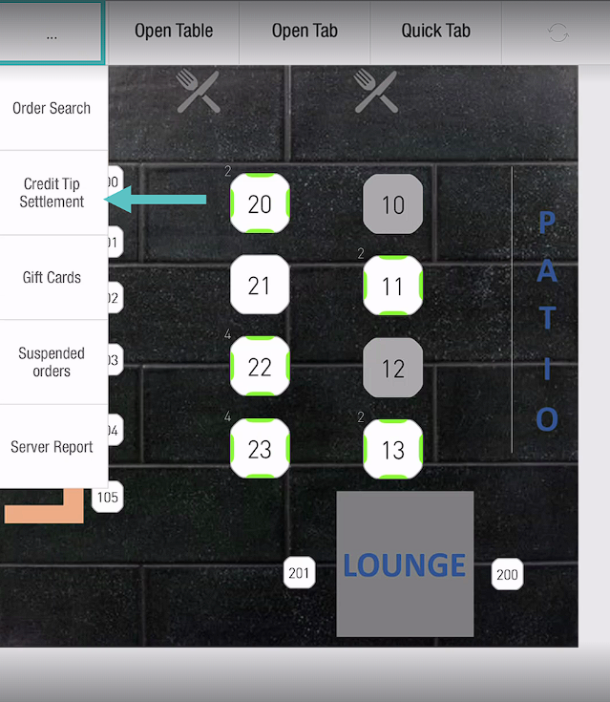

1. Choose the order that needs a tip adjustment.

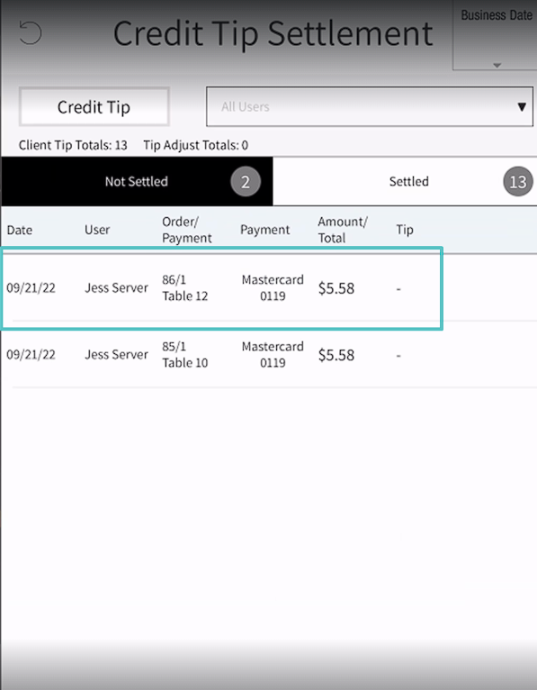

1. Enter either the tip amount or percentage.
2. Tap "**OK**" on the calculator, then tap "**OK**" at the bottom of the screen.

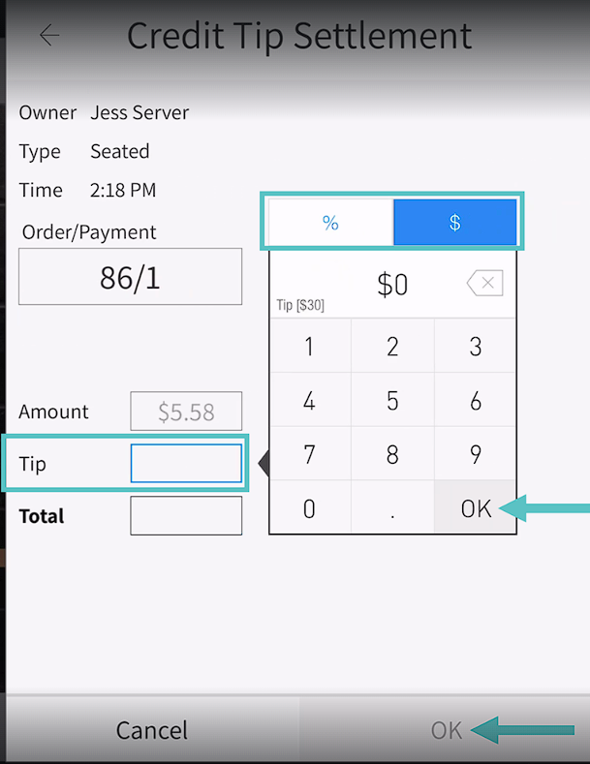

## For Managers:

1. Go to **Operation > Orders > Credit Tip Settlement**.

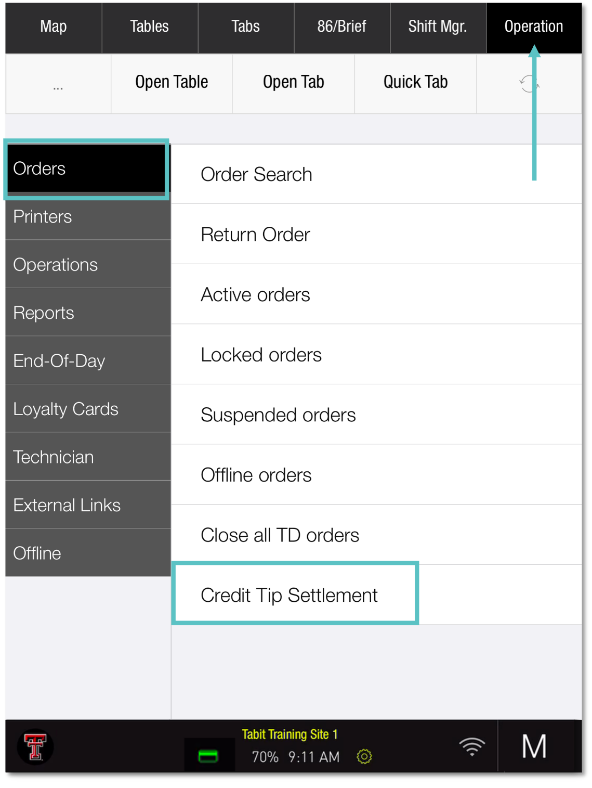

1. Select the order for tip adjustment.

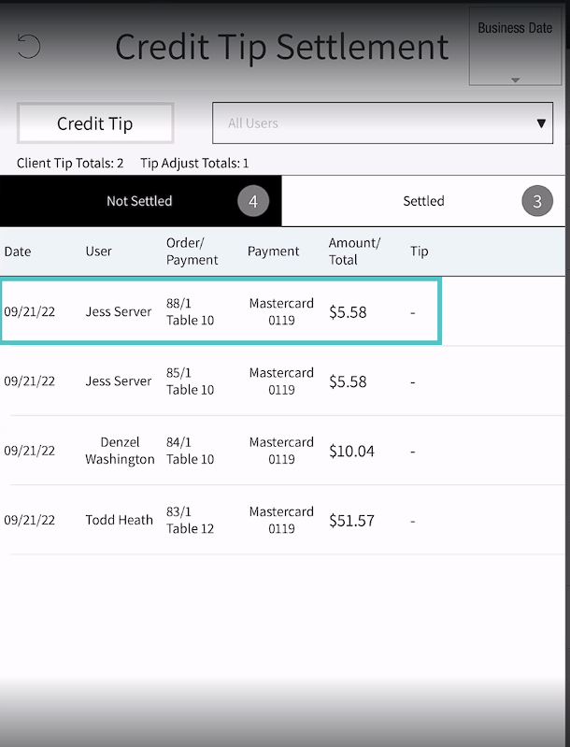

1. Enter either the tip amount or percentage.
2. Tap "**OK**" on the calculator, then tap "**OK**" at the bottom of the screen.

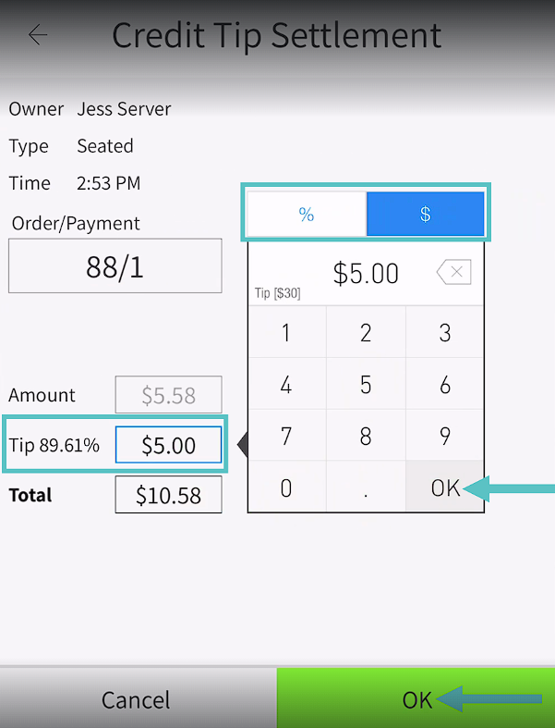

1. Back on the Credit Tip Settlement screen, a green icon will appear next to the adjusted order.

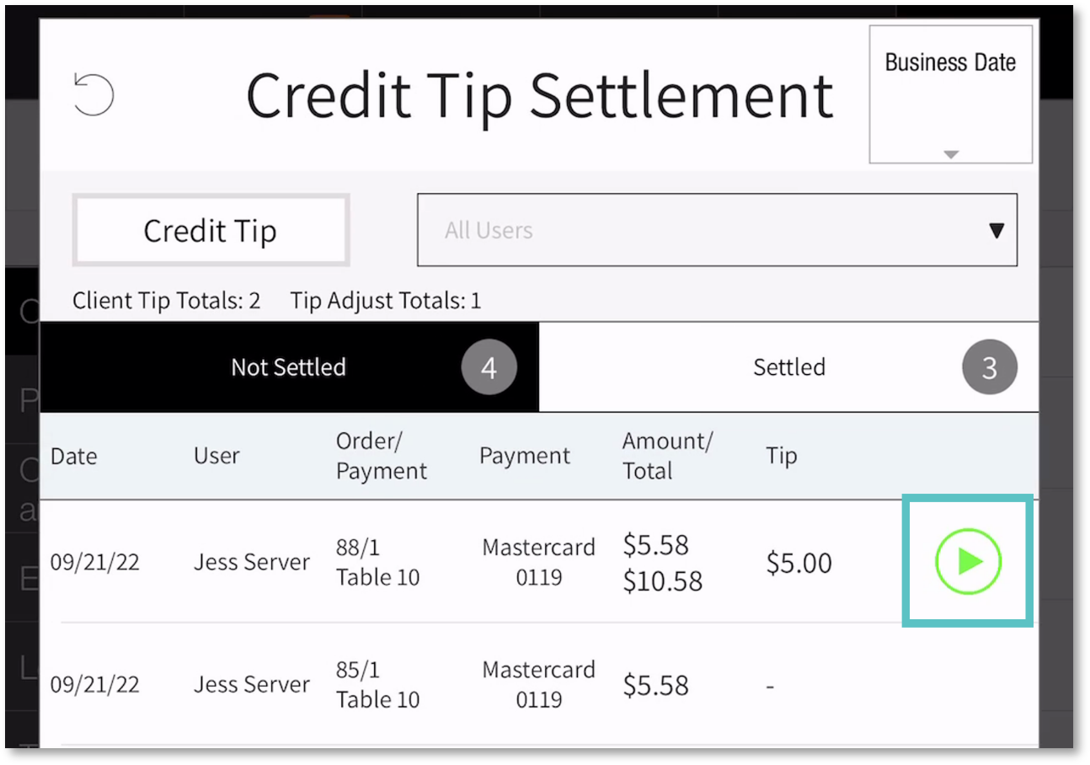

1. Tap the green icon to close the order. It will then move from "**Not Settled**" to "**Settled**."

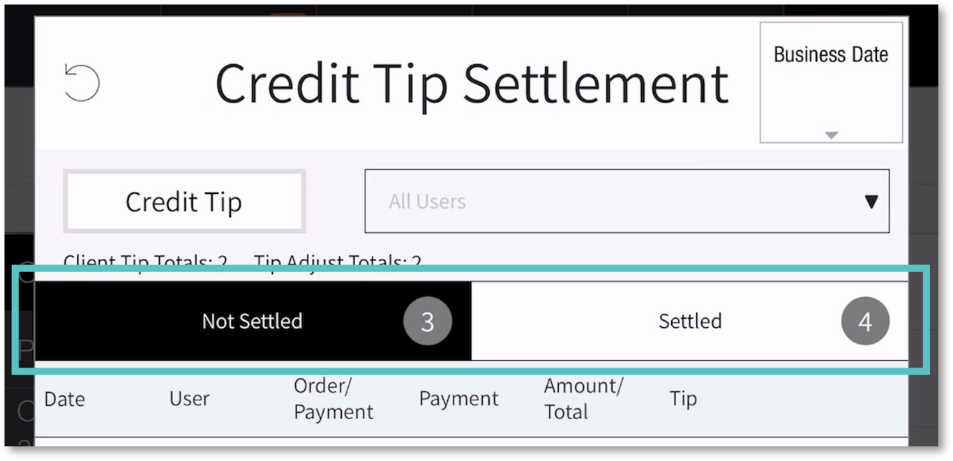

Repeat this process for each order until all are settled.

:light_bulb_on:If the green icon isn’t selected, the order will stay in the "**Not Settled**" tab.

***If you need further assistance, please call Flyght Support at 419-724-3115 or send us an email:*** [***support@whatisflyght.com***](mailto:support@whatisflyght.com)