How to Apply Auto Gratuity on the PAD

Contents

Follow the steps below to learn how to apply Auto Gratuity on the PAD: 3

Auto Gratuity can be applied to a Table at any point before payment is taken.

Follow the steps below to learn how to apply Auto Gratuity on the PAD:
- From the Order screen, select the Number of Guests at the top left corner of the screen
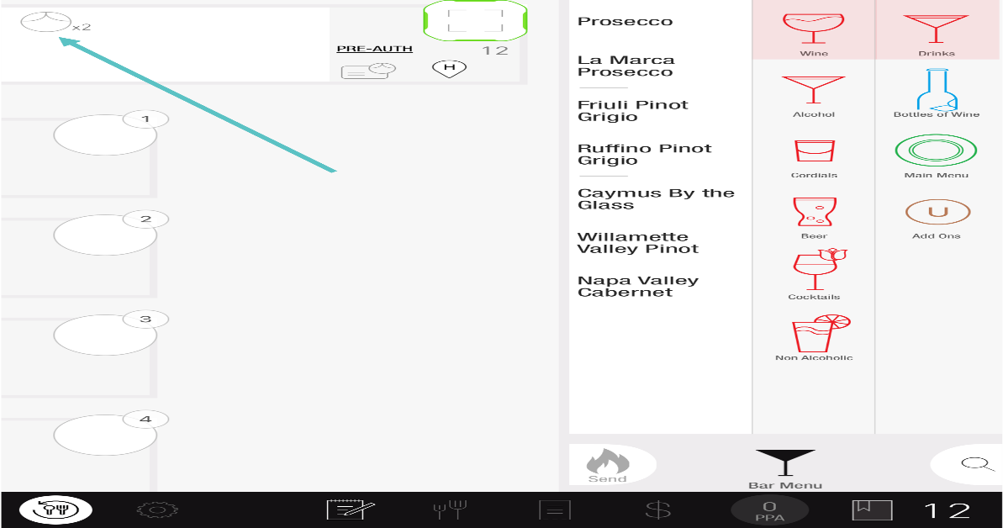
- Select how to apply the Gratuity
  - Apply Auto Gratuity: Automatically applies the gratuity amount set in Tabit Office
  - Apply Auto Gratuity Manually: Allows you to select a percentage or dollar amount to apply as Auto Gratuity
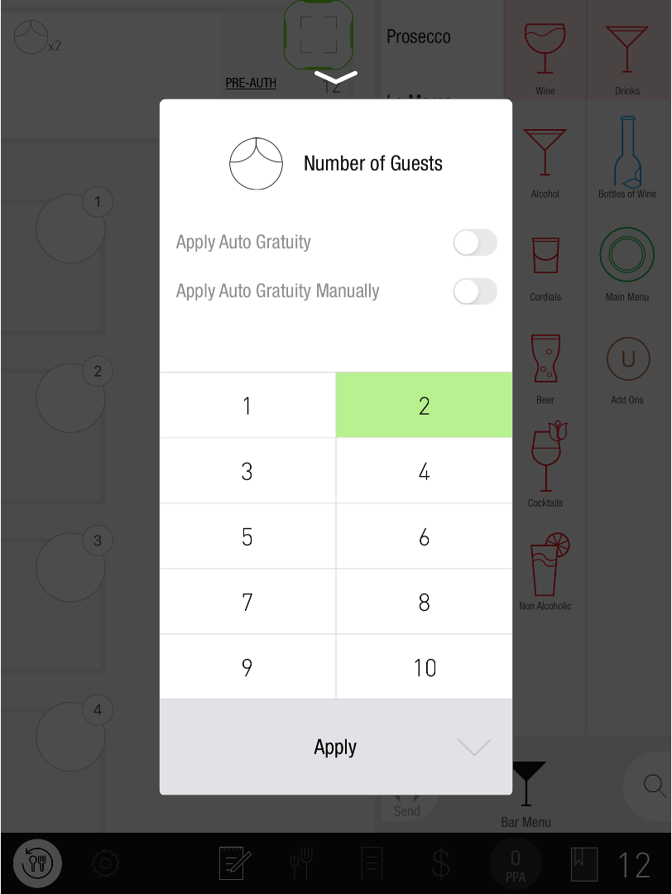
- Tap Apply
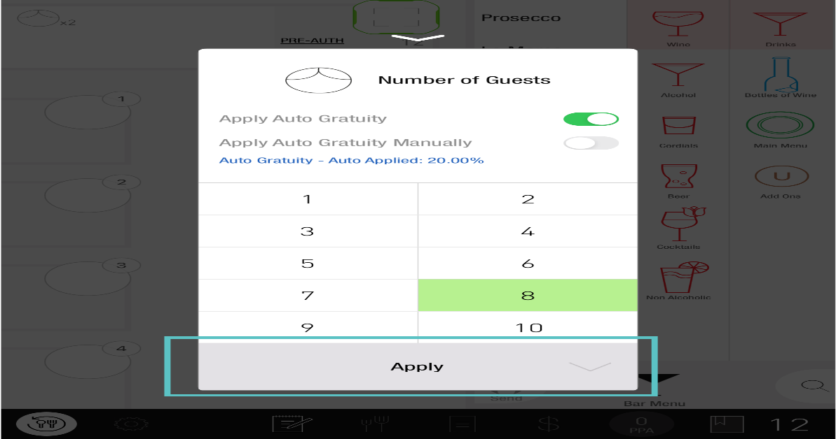

- Now Auto Gratuity has been applied to the Order
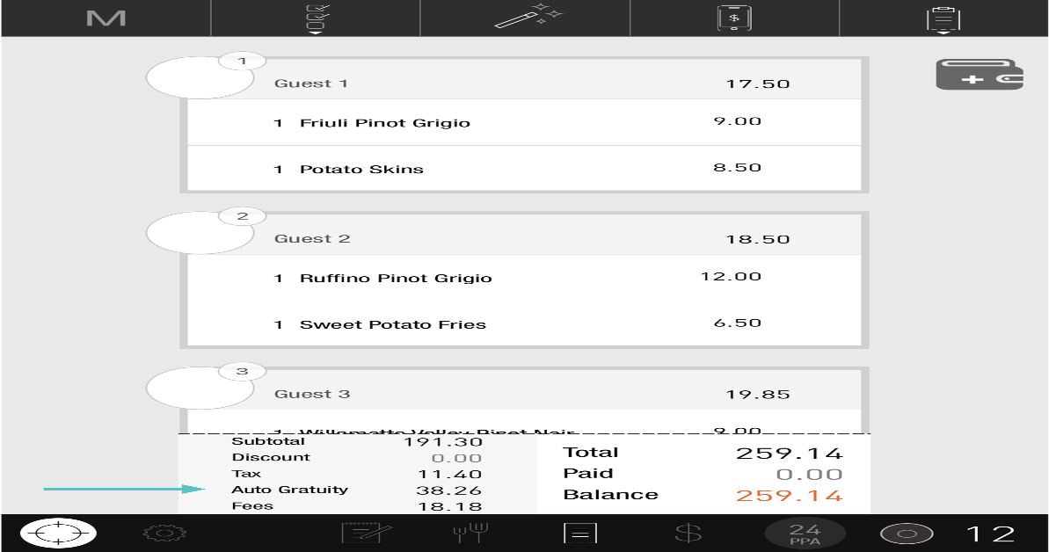

If you need further assistance, please call Flyght Support at 419-724-3115 or send us an email: support@whatisflyght.com

