How to Install a New

Ingenico Moby5500 Device

Contents

Office Setup 3
PAD Setup 3
Pairing the New Device 4

Before you begin, make sure the device is set up in Tabit Office.

Office Setup
- Log into Tabit Office with a Support Login.
- Navigate to Support > Payment Device Settings > Add.
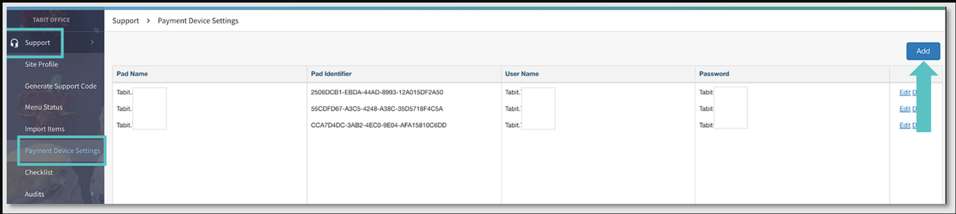
- Find the PAD Name.
- Enter your Username and Password.
- Click Save.

PAD Setup
Note: If you're replacing an old device, you might need to complete the following step first:
- On the PAD, go to Settings > Bluetooth. Find the old Moby5500 device and select Forget Device.
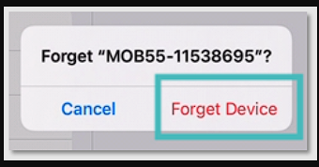

Pairing the New Device
- Turn on the Ingenico Moby5500 device (you should see a blinking blue and red light).
- Log into the PAD with a Manager Login and go to Operations > Technician > Ingenico Device Handler.
- Ensure the Ingenico user is logged in with the same credentials you used in Tabit Office.
- Select Pair and choose the Moby5500 device from the list (the device name usually starts with "MOB55-").
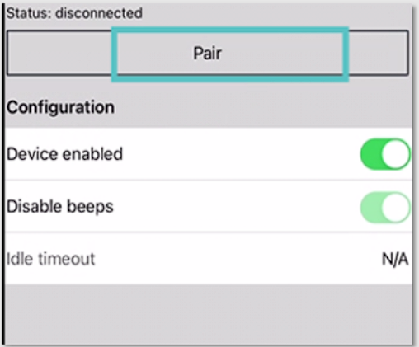
- A pop-up will appear asking to pair the device—select Pair.
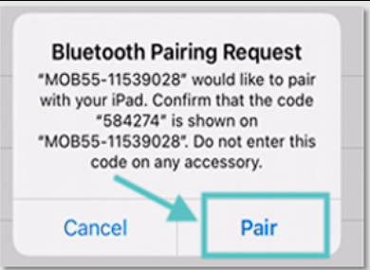
- Within 5 seconds, press and release the power button on the Ingenico device. This will trigger a light pattern on the PAD.
- The same pattern will also flash on the front of the Ingenico device. Wait until the light pattern disappears.
- Confirm the pattern on the PAD by selecting Confirm if they match.
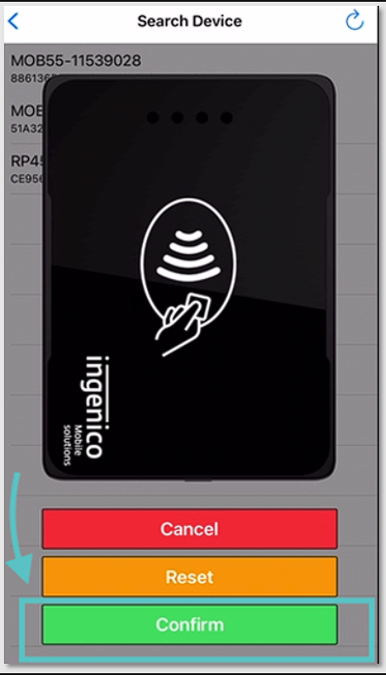
- When the setup is done, the blue ribbon on the PAD will display Insert/Tap/Swipe as the entry modes.

Your Ingenico Moby5500 device is now ready to use!

If you need further assistance, please call Flyght Support at 419-724-3115 or send us an email: support@whatisflyght.com

