Which One to Add:

A Text Decision or an Item Decision?

Contents

What is a Decision? 3
Best Practices for Adding Items to Decision Groups 3
Choosing Between Catalog Items or Free Text 4
Examples 4

What is a Decision?
A decision is when you ask the customer to choose something (like selecting options from a list or entering text) before an item can be ordered. Sometimes, these choices are automatically pre-selected but can be changed. Other times, the customer must answer the question before proceeding.
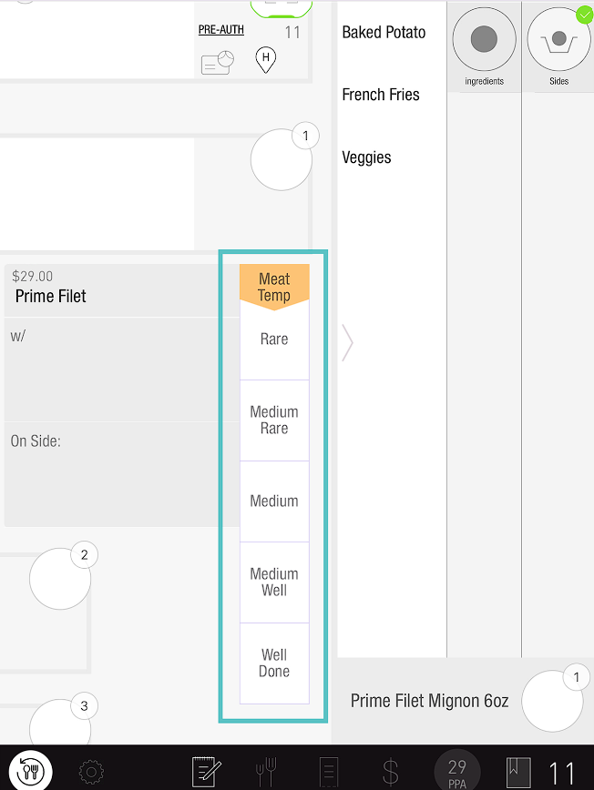

Best Practices for Adding Items to Decision Groups
- Always add items to the catalog: This helps track sales and manage stock levels. It also avoids the need to reconfigure things later.
- Difference from Modifier Groups: Unlike a modifier group, items in a decision group cannot have prices (so no upcharges or add-ons). If you need to charge more for an item, create a modifier group instead.

Choosing Between Catalog Items or Free Text
When setting up a decision, you can choose between using a catalog item or free text. Here's how to decide:
- Use a catalog item if:
  - You need to track sales.
  - You need to manage inventory and limit stock.
- Use free text if:
  - The decision doesn’t need to be tracked or limited.

Examples
- Meat temperature: This typically doesn't need to be tracked, so free text works.
- Salad dressings: These often need tracking in inventory, so use catalog items.

If you need further assistance, please call Flyght Support at 419-724-3115 or send us an email: support@whatisflyght.com

