How to Add or Remove a Promo Tag

Contents

Adding a Promo Tag 3
Removing a Promo Tag 6

Adding a Promo Tag

The Server will be able to apply a Tag, but Manager approval may be required for the Server to accept payment or print the check.
- From the Order screen, tap on the Card Icon and then select Add Tags
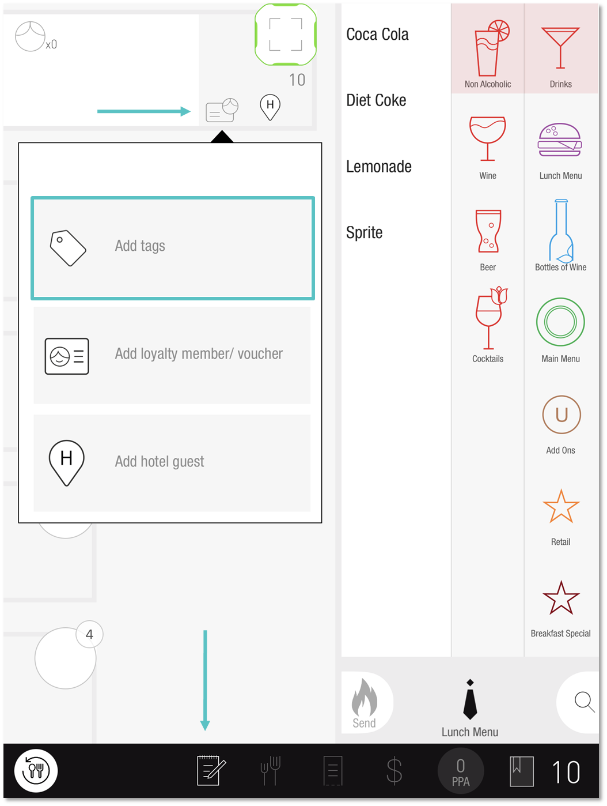

- Select the applicable Promo Tag and tap OK
📢The Tag will only affect the qualifying Item(s). If an Item is not included in the Promotion, the discount will not be applied
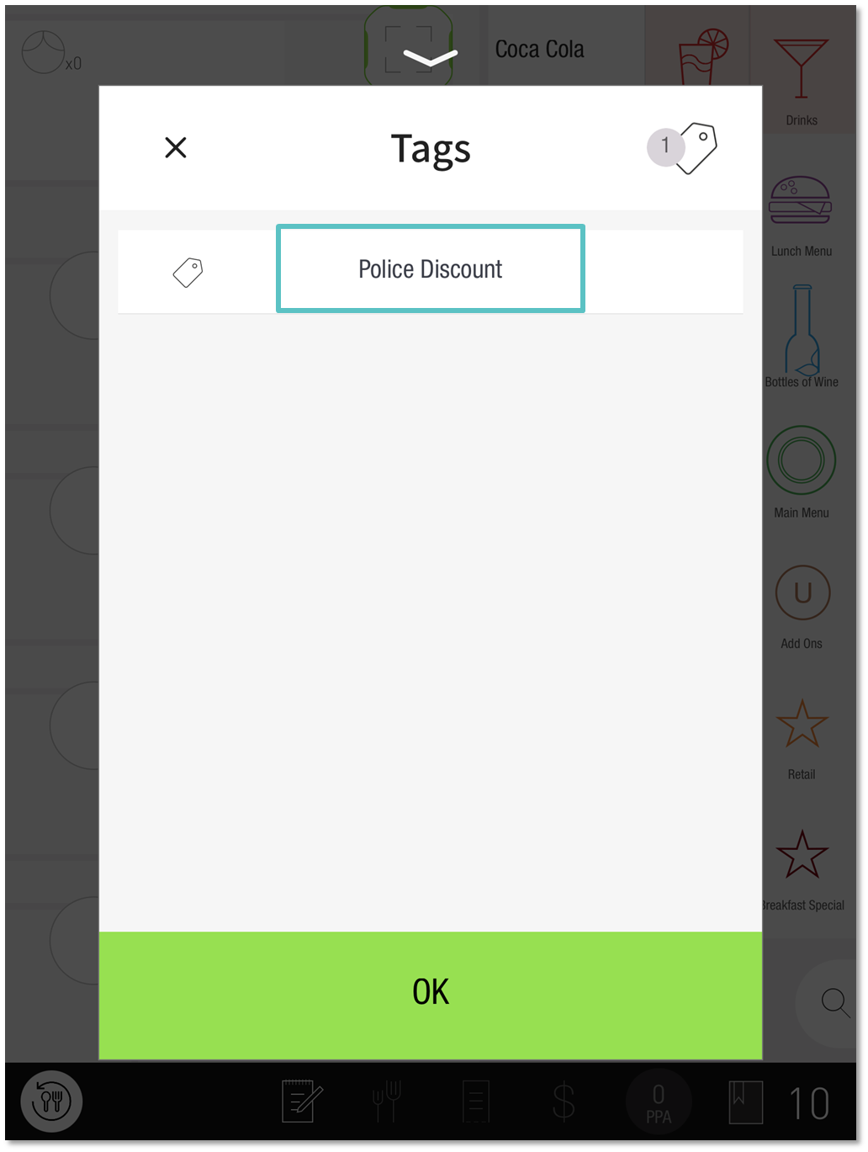
- Once applied, the selected Tag will appear in the shared seat next to the table number and an Orange M will indicate on the Check screen if Manager approval is required
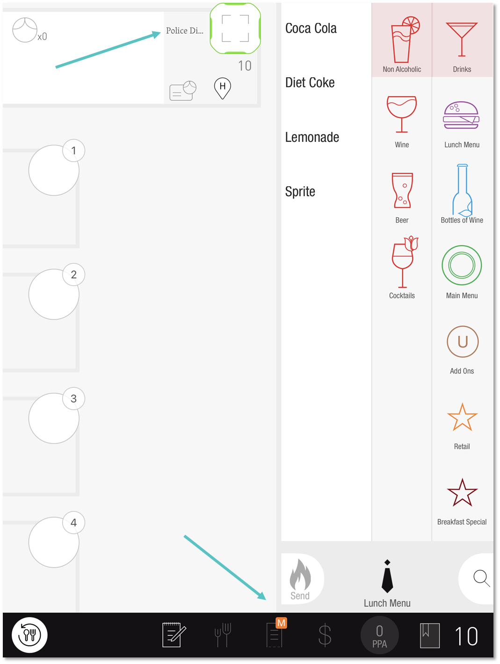

Removing a Promo Tag

📢A Manager will be required to remove the Tag if the orange M icon is showing.
- Tap on the Card Icon and then tap on the applicable Tag
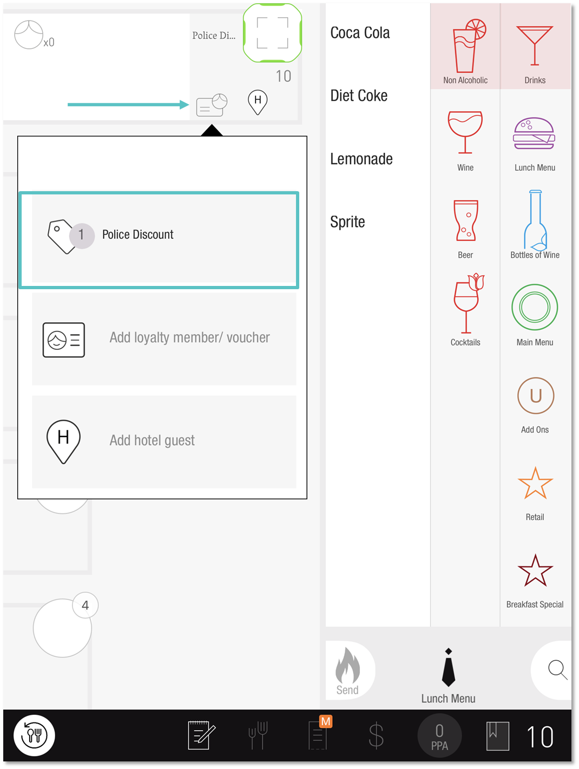

- Select the Tag that was previously applied and tap OK
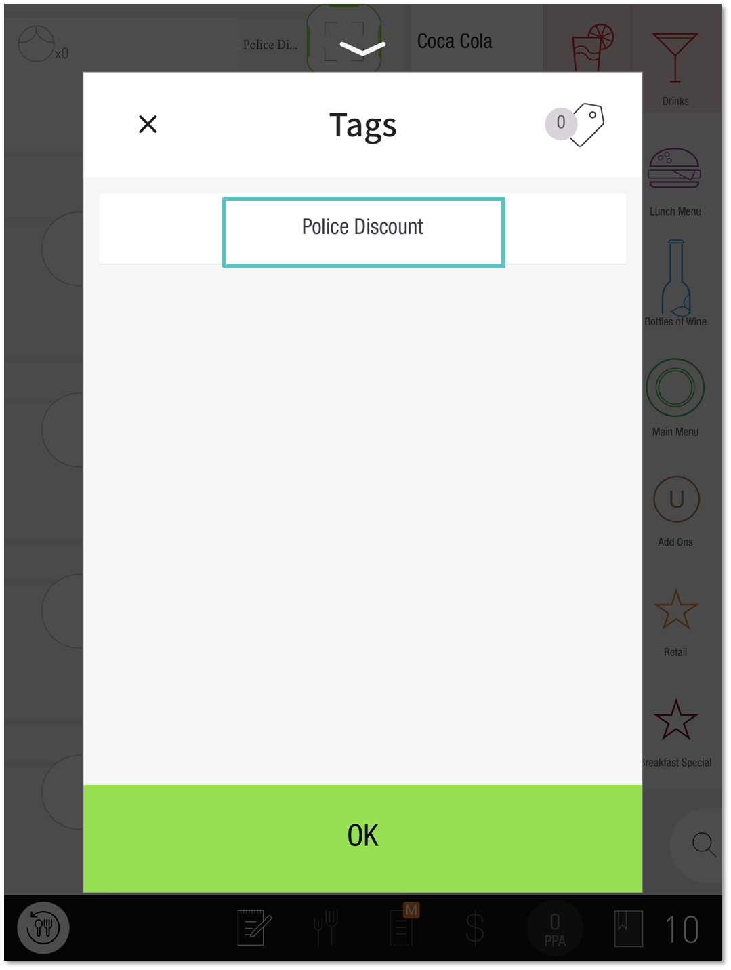
- The discount will now be removed
If you need further assistance, please call Flyght Support at 419-724-3115 or send us an email: support@whatisflyght.com

