How to Re-order Drinks

Contents

Follow the steps below to learn how to re-order another round of drinks from the PAD 3

Follow the steps below to learn how to re-order another round of drinks from the PAD
- From the Order screen, tap on the Spoon and Fork icon at the bottom left of the screen
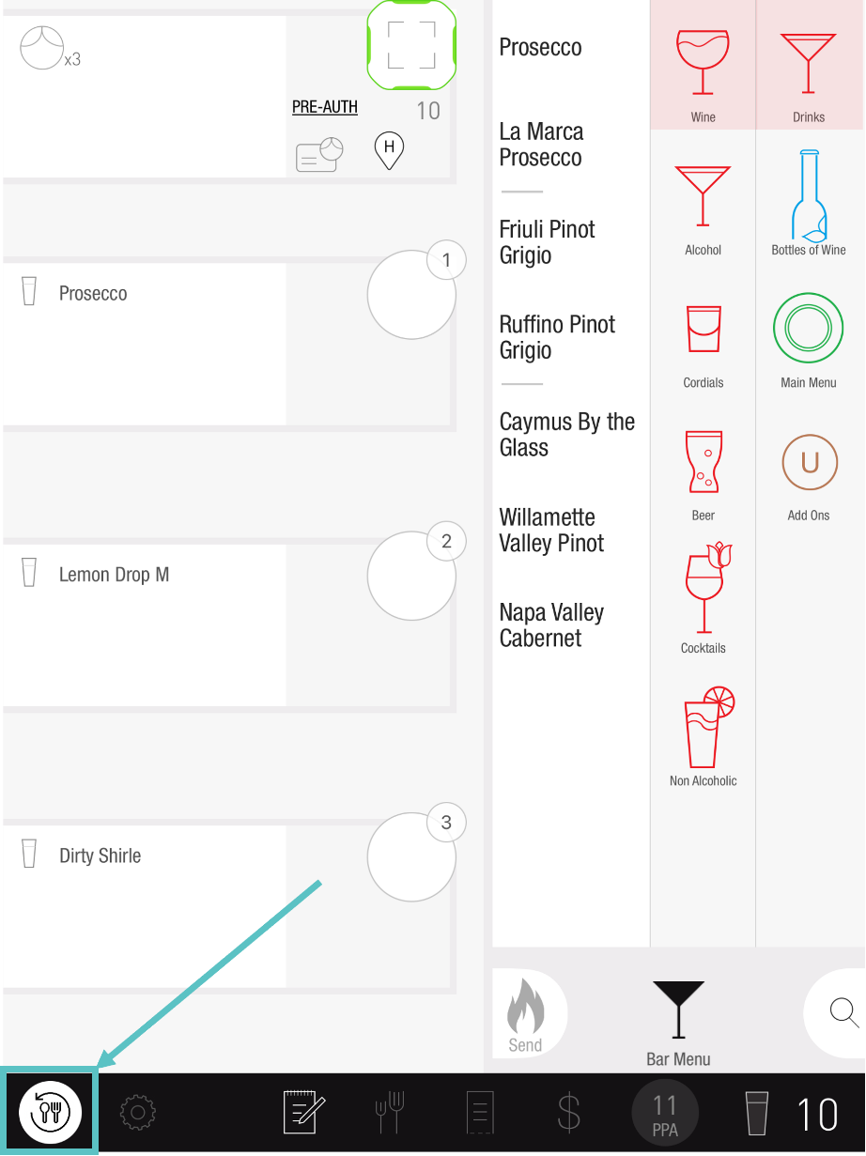

- Select which Items to re-order, or tap the button on the same line as the course icon. This will automatically select all
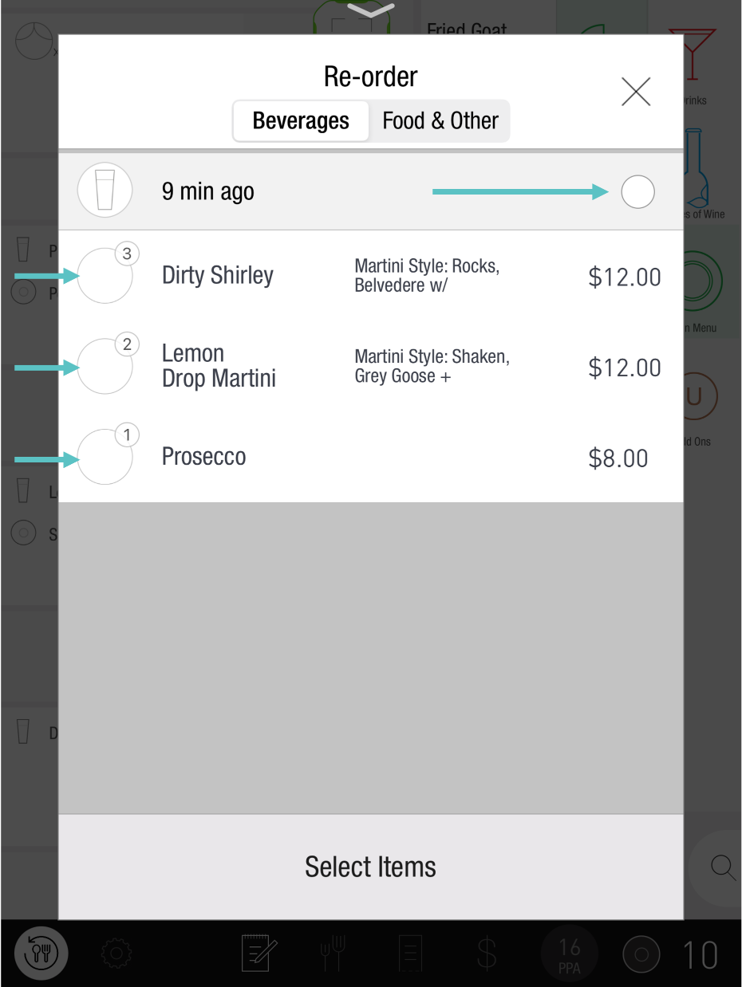

- Swipe left to fire the Order
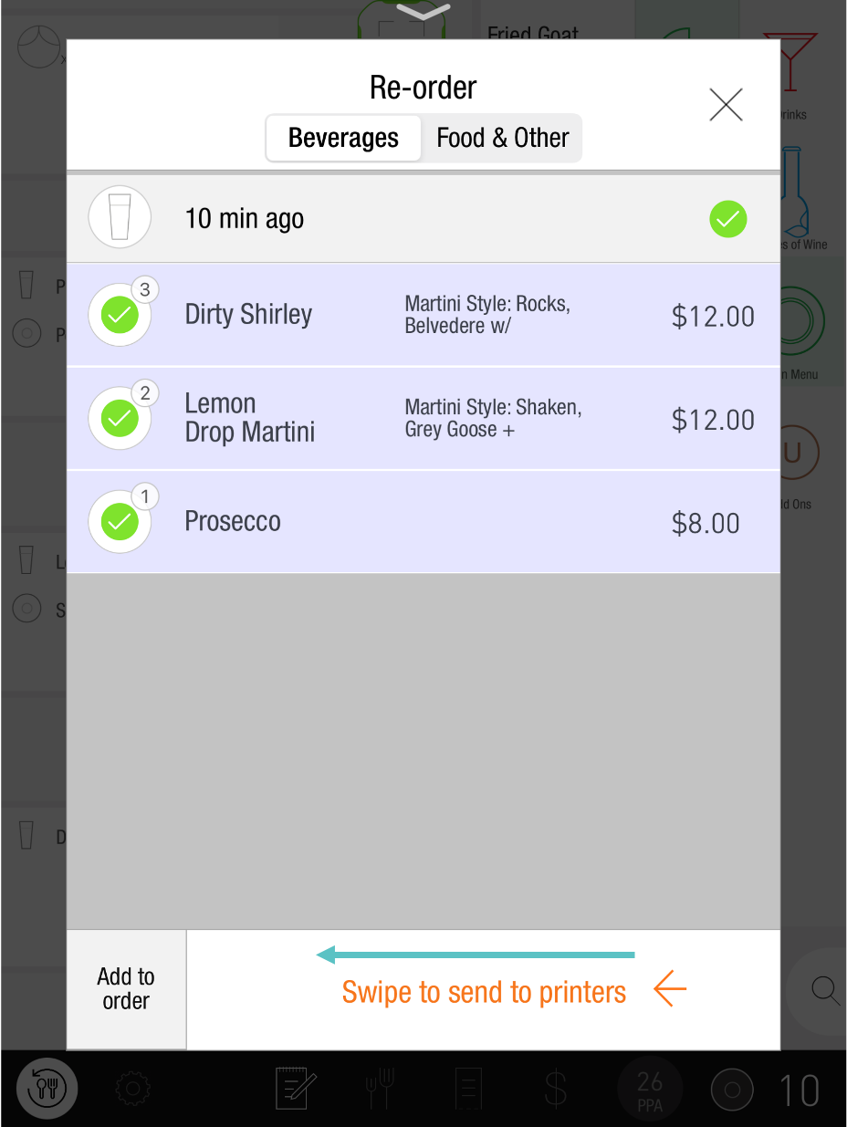

If you need further assistance, please call Flyght Support at 419-724-3115 or send us an email: support@whatisflyght.com

